Clover Hill Community Primary School

Glenhurst Drive, Whickham, NE16 5SJ

0191 433 4056

Email: cloverhillprimary@gateshead.gov.uk

Website: www.cloverhillprimary.org

Headteachers: Louise C Hall (BA Hons)
Ailsa Holden (BA Hons)

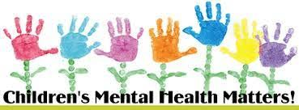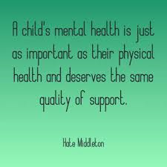

Children’s Mental Health Week: 3rd February 2025

The theme for 2025 is Know Yourself, Grow Yourself, with the aim to equip and empower children and young people across the UK to embrace self-awareness and explore what it means to them. We want our girls and boys to discover how getting to know who they are can help them build resilience, grow and develop.

Children’s Mental Health Week. The theme for 2025 is Know Yourself, Grow Yourself, with the aim to equip and empower children and young people across the UK to embrace self-awareness and explore what it means to them. We want children and young people to discover how getting to know who they are can help them build resilience, grow and develop.

The more we can understand about ourselves, the more prepared we are to express our emotions and take on life’s ups and downs.

Being self-aware means getting to know and understand what we are good at, what we find difficult, our likes and dislikes, what makes us feel JOY and what may cause us SADNESS. It is also about understanding what makes us unique and our fears, hopes and dreams. As we build a sense of self, we grow in our ability to connect with others, as well as develop our skills and talents. It is with this basis we can form strong and healthy relationships, from early childhood right through to adulthood and are equipped to cope with the challenges that life brings our way.

Help children recognise and express their emotions
It’s important that children feel comfortable talking about their emotions at school. Encourage children to label and share how they are doing with daily check-ins and quality conversations, Once children and young people start feeling more connected with their emotions, they will feel more comfortable opening up.

Reflect on emotions, especially after challenging situations
This really helps to create safe spaces for children and young people who are experiencing difficult emotions and thoughts. It can give them the chance to share what is going on inside of them and develop healthy ways to navigate life.

Setting goals Setting goals for our future helps us get to know ourselves and each other. It helps us focus on our hopes, dreams, and what we believe we can achieve. During this process, it is key to keep the child at the centre and understand what matters most to them.

Active listening Active listening involves fully focussing on what a child is saying, and showing you understand by responding thoughtfully. Children often state what helps them most is knowing someone is truly listening.

Creativity Embracing and developing creativity is a fantastic way to help your child grow. Whether through art, writing, playing an instrument, or computer coding, creativity helps children express who they are and the emotions inside of them.

The start of a new year often brings the desire to set up a healthier lifestyle When we think about healthy living, we tend to focus on looking after our bodies, our physical wellbeing – through food, being active and getting enough sleep. However, to be healthy overall, it’s important that we look after our minds - our mental wellbeing too! This is something we prioritise at Clover Hill and are passionate about supporting our children. We do this by teaching them about resilience, kindness and celebrating uniqueness. We create nurturing support but also facilitate self-help and self-belief teaching to build up resilience and confidence. Anxieties can often be resolved when we are better at understanding ourselves and others. Taking control of a situation, putting it into perspective and thinking through positive self-help support strategies.

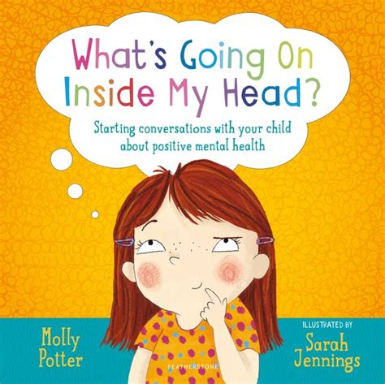

Yours truly
Louise C Hall and Ailsa Holden
Headteachers

