Happy news for Clover Hill – we have just been awarded the Schools Health and Wellbeing Award. We have lots to be proud of and lots to be grateful for.
Our staff work so hard to ensure that our children are at the heart of everything we do. The investment in our children isn’t just about academic excellence but also their personal and social development to create healthy, happy and well-rounded young individuals.

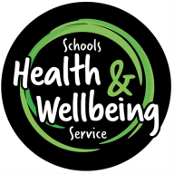
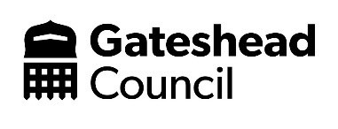

Miss L Hall / Mrs A Holden  Clover Hill Community Primary School  Glenhurst Drive  Whickham  Newcastle upon Tyne  NE16 5SJ | Date: 21st May 2024
Dear Miss Hall and Mrs Holden

Thank you for your school’s recent application for the Schools Health and Wellbeing Award (SHWA).

As you may be aware, all applications are reviewed by a validation panel who request a range of supporting evidence as part of the quality assurance process for this award framework.

Following review of all the evidence, we are delighted to inform you that Clover Hill Community Primary School has successfully achieved the Schools Health and Wellbeing Award.

As a SHWA School
The Schools Health and Wellbeing Service (SHWS) exists to support and encourage school development within the area of health and wellbeing. As a SHWA school, you are recognised for the work you are doing to develop and enhance your existing level of provision through engagement with this award framework and the associated self-review process.

We celebrate your commitment to developing and enhancing health and wellbeing within your school. In turn we would also like to thank you for your contribution to the overall vision of this service:

…the belief that ALL children and young people have a right to be healthy and that healthier children are more likely to achieve at school and in life.

…School health and wellbeing is not just about children and young people; it is about involving the whole school and wider community together with local services and agencies.

You will receive a framed certificate to be displayed in school as well as a logo that you are welcome to use on your headed paper etc.

Your award is valid until 21/05/26 (two years), subject to the completion of a review at the end of year one.

Once again, a huge congratulations on the achievement of your Schools Health and Wellbeing Award.

Best wishes,

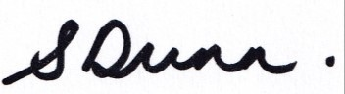

Suzanne Dunn
Service Director
Education, Schools & Inclusion
Childrens Social Care and Lifelong Learning

