Clover Hill Community Primary School

Glenhurst Drive, Whickham, NE16 5SJ

0191 433 4056

Email: cloverhillprimary@gateshead.gov.uk

Website: www.cloverhillprimary.org

Headteachers: Louise C Hall (BA Hons)
Ailsa Holden (BA Hons)

Headteachers’ Message
What a fantastic first three weeks we have had! The superb attitudes and positivity of the children has continued and the atmosphere in school is amazing. Reception class have settled in really well and their Year 6 buddies are doing a brilliant job at break times engaging them in play and helping familiarise them with our school grounds and routines.

Lockdown Policy and Drills
As part of our safeguarding procedures in school, we have a plan for “lockdowns” in the event of a school threat (just like we do in the case of a fire).

Lockdown procedures are important and would be used in response to an internal or external incident which could be a threat to the safety of staff and children in the school.
Lockdown procedures may be activated in response to any number of situations, these may be:
- A reported incident, disturbance in the local community
- An intruder on the site
- A warning being received regarding a local risk of air pollution (smoke plume, gas cloud etc.)
- A major fire in the vicinity of the school
- The close proximity of a dangerous dog roaming close

In the event of an actual lockdown, any incident or development will be communicated to parents as soon as is practicable. Parents will be given enough information about what will happen so that they:
- Are reassured that the school understands their concern for their child’s welfare, and that it is doing everything possible to ensure his/her safety.
- Are aware that they do not need to contact the school, because the school is following an agreed safety procedure and that calling the school could tie up telephone lines that are needed for contacting emergency providers.
- Are aware that they do not need to come to the school because this could interfere with emergency services access to the school and may even put themselves and others in danger.
- Wait for the school to contact them about when it is safe for them to come and collect their children, and where this will be from.
We will be carrying our termly lockdown drills in addition to our termly fire drills.

School Council
Elections for our school council took place this week. We are delighted to announce our new school councillors (as voted for by their classmates) for this year. Well done to everyone who put themselves forward into the election.
Year 3: Benjamin and Daniel
Year 4: Darcy and Thomas
Year 5: Josh and Phoebe
Year 6: Layla and Alex

School Librarians
Our Y4 school librarians were trained by our Year 6 librarians during the Summer Term (prior to them leaving us) ready for them to take over the role. They are responsible for keeping the library tidy and choosing a ‘theme of the week’ and ‘author of the week’ and creating display for both of these. Please watch out for them!!

Please speak to any of the girls below should you have any requests or questions about the library:
Isla H, April, Connie, Sophia S, Tabitha, Millie.

School Football Team
Trials took place for our school football team last week.
The 7 a-side squad for this season are:
Kai, Jack, Alex, Alex, Hope, Lauren, James, Leonardo, Bobby.

The team played their first match last night. Mrs Feeney and Miss Sinclair said they displayed excellent sportsmanship skills aswell as playing some extraordinary football. We are proud of you.

Our ‘Girls Only’ team has also been selected:
Lauren, Hope, Layla, Liv, Darcey, Hope, Eleanor, Lily

We wish them lots of luck and know they will represent our school superbly.

Cross Country Trials
Miss Sinclair will be holding cross country trials (in preparation for the Gateshead Schools Cross Country Run at Watergate Park on Wednesday 2nd October) over the next week during PE sessions and Athletics club. Children will be expected to run 1 mile for UKS2 and 3/4 mile for LKS2. Your child should speak to Miss Sinclair if they are interested in taking part in this. Numbers are limited and places will be allocated on merit. We have had much success with this event over the years and thoroughly enjoy taking part.

Athletics Club Sponsored Fun Run
We are so grateful to everyone who supported our Athletics Club sponsored fun run in July. The totals have just been counted and we are astounded to share with you that it raised just under £700!!! We are going to use this to supplement our Sports budget and ensure we our children receive the best opportunities through good quality resources.
School Lunch Extravaganza
On Friday 3rd October, there is a change to our school meal. We will be having a party lunch as a special treat! Menu to follow.
Marvellous Me App!
Our Marvellous Me app is now fully working and parents from Year 1-Year 6 should all have full access to receive messages and ‘thumbs up’ for their child. The ‘thumbs up’ system replaces team points and children can trade the ‘thumbs up’ at the end of each half term for a special treat!!

This can include: a HT sticker, extra playtime, choosing where they want to sit for the day, hot chocolate with a friend, hot chocolate with the teacher, lucky dip… the list goes on!! This system has proved to be very popular over the last academic year and really motivates the children.

Homework
Homework is set using the MyMaths and Spelling Shed online programmes which is linked to learning in class for that week. It is crucial that your child completes their weekly set task. We would really appreciate everyone’s support with this as per our home-school agreement. Children who do not complete their homework miss out on the opportunity to embed the learning taken place for that week and this could impact on retention.
Hometime
It is lovely to see the children enjoying our playground at the end of the day – they sometimes don’t want to leave!! However, Mr Toomer needs to lock our gates at 3.35pm prompt to get on with other school priorities. For safeguarding reasons, we cannot leave the gates unattended.
We would appreciate your support with this.
Asda Cashpot for Schools
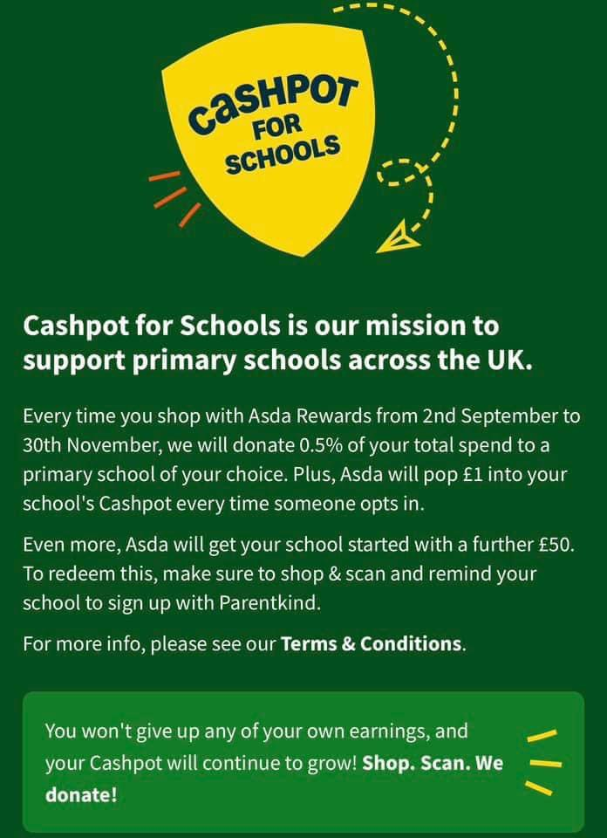 |  | Did you know ASDA Rewards gives you the opportunity to choose a school when you shop with them?  ASDA will then donate 0.5% of the cost of your shopping, to us. It costs you absolutely nothing but can make a HUGE difference to us.  ANYONE can do this so please start sharing with your friends and family.  Our cashpot total stands at: £176.91  If you’d like to choose us, we would be very grateful!

Our whole school attendance figure for this week is:
97.4%

Our star class attendance award goes to:
Year 6 with 98.3% attendance

They will receive 5 extra Marvellous Me points each.

Important diary dates | INSET Days - school closed to pupils.  - Friday 21st February 2025  - Monday 2nd June 2025  Occasional Day  Friday 20th June 2025: School closed to staff and pupils.  Halloween Disco  Tuesday 22nd October.  KS1 3.45-4.45 KS2 4.45-5.45.  Further information to follow.  School Photographs  Thursday 3rd October  Gateshead Schools Cross Country Competition at Watergate Park  Wednesday 2nd October  Further information to follow should your child be selected.

