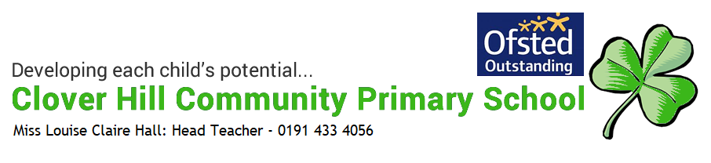

Early Writing Policy
What does early writing look like in Reception at Clover Hill?
Intent
We would like to:
- ensure our children are articulate and can structure their ideas in speech.
- ensure our children foster a love for language and communication.
- ensure that children are exposed to a wide and rich diet of print and are supported in the development of their writing skills.
- promote a positive ‘can do’ attitude towards learning to write where all progress is acknowledged and celebrated and where a climate of challenge encourages children to work hard and persevere.
- foster a love of mark making and writing in our children from the very start of their time with us.
- utilise the strong links we have with our very supportive families and ensure that parents and carers are involved and informed throughout their child’s learning to write journey.
- ensure our children achieve their Early Learning Goal for fine motor skills and writing by the end of their Reception year.
Implementation
Organisation and Delivery of mark making and writing in Reception
We start our early mark making and writing journey with opportunities to develop fine motor skills on a daily basis, this includes daily dough disco during the autumn term and activities using a range of resources that are set at our fine motor table. We find time at least once per day to share stories, rhymes, poems and songs with the children. This is always a favourite time of the day and we use to it develop children’s story language and confidence to share ideas and express feelings within the group. The use of high quality texts aims to ensure all children reach their potential when engaged in mark making and early writing. The learning environment is print rich and provides appropriate support for age related learning of writing. When the adults in the class are engaged in play with the children we use these opportunities to develop and extend the language that children are exposed to and then use. As soon as they join us in Reception children learn that writing can have a range of purposes and they begin to explore the features of different types of writing. It is important for the children to see the adults in the classroom write, so each day starts with our message board being completed. Opportunities and a wide range of resources for mark making and writing are available in many areas of the indoor and outdoor environment, we also provide mark making resources that can be transported around the environment. Children are actively encouraged to give meaning to the marks they make. Independent mark making and writing are celebrated and shared on each child’s “special square” on the classroom wall. Children also participate in regular adult led writing activities which are closely linked to our phonics curriculum. As we introduce new phonemes we also spend time looking at and exploring the correct formation of the associated grapheme. In addition to this as we develop blending skills we also look at the skill of segmenting in order to write words.

Impact
The majority of children leave Reception with solid foundations instilled having achieved the expected level of development in physical development (fine motor skills) and literacy (writing). They are therefore fully equipped with the skills required to continue their progress in writing in Key Stage One, following the National Curriculum.
Monitoring and Evaluating Writing
Teaching and learning is monitored through planning and assessment scrutiny, lesson observations, work scrutiny and through talking to the children while they are engaged in the environment. This provides a basis to evaluate writing effectively.
Assessment, Recording and Reporting Formative Assessment
Assessment in Reception is a continuous and ongoing feature of the classroom and is largely carried out through observations and discussions with the children. We watch for children using their developing mark making and writing skills within everyday situations in the classroom. As previously mentioned independent mark making and writing are celebrated and shared on each child’s “special square”. Each piece, when added to the square is dated to therefore show progression across the Reception year. Some of our assessment and record-keeping for writing is completed during our observations of children during adult led writing activities. We complete a progress check in December and March to judge whether children are on track or not on track to achieve the Early Learning Goals in writing and fine motor skills. (See also Early Years Assessment Policy.)
Inclusion
Children for whom we have concerns regarding their progress in writing are targeted quickly for focussed intervention, this happens daily and aims to support children in addressing the gaps in their knowledge and skills. We aim to identify children who may have speech or oral language impairments as early as possible as this can impact on their later development of written language skills. As this is closely linked to phonics progress, more information regarding assessment and intervention can be found in the Phonics Policy.

