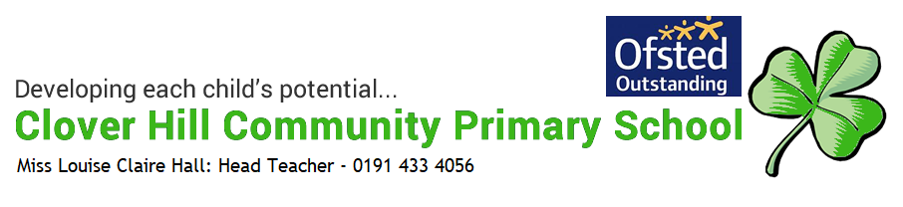

Early Mathematics Policy

What does mathematics look like in Reception at Clover Hill?
Intent
We would like to:
- Develop a strong grounding in number so that all children develop the necessary building blocks to excel mathematically.
- Ensure that all children can count confidently.
- Ensure children develop a deep understanding of the numbers to 10, the relationships between them and the patterns within those numbers.
- Provide varied practical opportunities to build and apply understanding of numbers to 10.
- Provide opportunities in order to develop a secure base of knowledge and vocabulary from which mastery of mathematics is built.
- Provide opportunities for children to develop their spatial reasoning skills across all areas of mathematics including shape, space and measures.
- Develop positive attitudes and interests in mathematics.
- Provide opportunities for children look for patterns and relationships, to spot connections and to ‘have a go’.
- Ensure children talk to adults and peers about what they notice and not be afraid to make mistakes.
Implementation
Organisation and Delivery of the Mathematics Curriculum in Reception
We spend time each day fostering an interest in mathematics and weave mathematical concepts throughout many of our daily activities. Each morning we begin with our register, message board and lunch choices; during this time, we look at number in our daily routine which has real life relevance in order for our day to run smoothly. During this time the children are engaged in counting and looking for patterns and relationships. We discuss how many children are present, how many are absent, how many children are going to after school club and how many of each lunch choice we need to order from the school kitchen. We look at tallying and work out whether each number is odd or even.
We have developed our mathematics curriculum by using the BBC Numberblocks series alongside supporting resources produced by NCETM as its core. Numberblocks is a BBC television series aimed at introducing children to early number. The Numberblock characters combine with engaging storylines to gently introduce concepts of number to support early mathematical understanding. The NCETM supporting resources use each episode as a launch pad. These resources enable practitioners to confidently move on from an episode, helping children to bring the numbers and ideas to life in the world around them. They highlight and develop the key mathematical ideas that are embedded in the programmes. We ensure that we have high quality and open ended mathematics resources readily accessible in our indoor and outdoor environments to enable children to lead their own learning and to develop their mathematical knowledge. We also ensure we provide relevant and stimulating resources in our provision that will further support the aspects of mathematics that we are focussed on in any one week, please see enabling environments on weekly maths plan. Children will also participate in small group adult led sessions.
Impact
The majority of children leave Reception with solid foundations instilled and are fully equipped with the skills required to continue their mathematics education in Key Stage One, following the National Curriculum.
Monitoring and Evaluating Mathematics
Teaching and learning is monitored through planning and assessment scrutiny, lesson observations, work scrutiny and through talking to the children when engaged in the classroom. This provides a basis to evaluate mathematics effectively.
Assessment, Recording and Reporting Formative Assessment
Assessment in Reception is a continuous and ongoing feature of the classroom and is largely carried out through observations and discussions with the children. We watch for children using their developing mathematics knowledge within everyday situations in the classroom. Significant observations are recorded on each child’s “Snapshot” assessment. We assess each child at the end of each term using individual mathematics assessment booklets. Both the “Snapshot” and “Mathematics Assessment Booklet” are readily available and shared between the Early Years Team.
Inclusion
Children for whom we have concerns regarding their progress in mathematics are targeted quickly for focussed intervention which happens daily and aims to support children in addressing the gaps in their knowledge and skills.

