# Clover Hill Primary School

# Phonics Policy

**Intent**

We would like:

* children to use a ‘phonics first’ approach when learning to read and when faced with unfamiliar words.
* to deliver fun, interactive and multi-sensory phonics lessons with high levels of pupil engagement.
* to provide a systematic phonics curriculum that builds on attainment and ensures progressions alongside regular opportunities for over-learning.
* to use a rigorous assessment system that closely monitors progress and quickly identifies children not making progress and enables timely and targeted intervention.
* to make effective use of our supportive parents by ensuring that they are fully informed about the way phonics is taught at Clover Hill and how they can bet support their child with phonics at home.

**Implementation**

**Organisation and Delivery of Phonics**

In Reception and Key Stage One, we use Phonics Shed which is validated by the Government and links with Spelling Shed which is used in school from Year One onwards. We have overviews which detail the GPCs and Tricky Words to be taught each week and these are used by all members of teaching staff to ensure consistency of approach. Phonics Shed includes detailed lesson plans with scripts and consistent resources which means that practice is mirrored from one class to the next.

We realise the importance of effective first teaching in phonics and therefore invest a significant amount of teaching time into its delivery. In line with the recommendations made in the Reading Framework: teaching the foundations of literacy (DfE 2021), we aim to spend approaching one hour per day on developing children’s phonics ability at the end of the Reception year and into Year One. Due to the young age of the children, this will take the form of short, highly interactive sessions carried out across the day rather than all in one sitting.

We believe in the importance of giving children opportunities to practise and apply their developing reading and spelling skills and so aim to ensure that dictation features highly in planning. In Reception class, we take advantage of children’s high level of focus at the start of the day and use our first 15 minutes in the morning to practise letter formation, segmenting and spelling.

Phonics is taught daily in Year One with lots of opportunities for consolidation and over-learning.

**Homework & Engagement with Families**

We are fortunate to have supportive parents at Clover Hill who are willing to reinforce classroom learning at home and we capitalise upon this by sending home a phonics challenge each week for the children to complete with their families. In order for support at home to closely follow in-school learning, we film a Reception weekly phonics recap each Friday which includes a summary of the week’s learning. This gives us the opportunity to share the correct terminology and techniques with parents which we have found to be very successful.

**Assessment in Phonics**

When children join us in September of Reception, we carry out Baseline Assessment to start building a picture of each individual child, their strengths and targets. During this period, we deliver daily sessions to develop children’s phonological and phonemic awareness in preparation for the introduction of GPCs (grapheme / phoneme correspondences) that come with Chapter 2.

At Clover Hill, we firmly believe in children ‘keeping up’ rather than ‘catching up’ and so have created the Clover Hill Phonics Assessment Book which is linked to Phonics Shed and is completed at appropriate intervals throughout a child’s journey through the Phonics Curriculum in EYFS and KS1.

All children receive “Quality Whole Class Teaching” with support and scaffolding to give all children the opportunity to succeed and make progress. Children’s progress is closely monitored through ongoing formative assessment by teaching staff and also assessed summatively in scheduled Assessment Weeks. During these weeks, staff complete each child’s Phonics Assessment Book.

In June of Year One, children complete their Phonics Screening Test which gives further information regarding children’s phonics skills. Children who do not meet the expectation are given targeted intervention and re-assessed in Autumn Term of Year Two

**Intervention**

Children who do not make the expected progress and complete a phase in line with the class, are given daily targeted intervention to support them to keep up with their peers. The Phonics Assessment Book gives staff detailed information regarding each child’s developing phonics skills and so enables staff to deliver targeted intervention to enable them to close gaps. The Assessment and Intervention Flowchart (appendix 1) shows teaching staff how to address gaps and misconceptions and directs them to the appropriate resource to use in intervention sessions. At the end of the intervention period, children are re-assessed and intervention is adjusted accordingly. If, at the end of this second set of intervention sessions children are not making progress and the gap is not closing, we will seek specialist advice and place the child on our SEN register.

**Reading**

We use Big Cat phonic reading books and these are closely aligned with Phonics Shed. This enables children’s developing phonic skills taught in school to be practised and refined at home and at school. We have detailed and rigorous systems in place for the allocation of reading books as detailed in our Early Reading Policy. Our Reading Record Sheets detail the current GPC knowledge of each child and allow members of teaching staff to allocate home reading books that include only GPCs that a child has already mastered. In order for children to read with sufficient fluency to ensure comprehension, we often allocate reading books slightly behind a child’s GPC level. (Appendix 2 and 3)

**Moving on From Phonics**

Phonics lessons continue to the end of the Autumn Term in Year Two when the focus changes to Spelling Shed. Children move through the reading scheme from the decodable reading books (pink, red, yellow, blue, magenta, green, orange and turquoise) onto the purple books onwards when their sight vocabulary enables them to tackle these texts with fluency and comprehension.

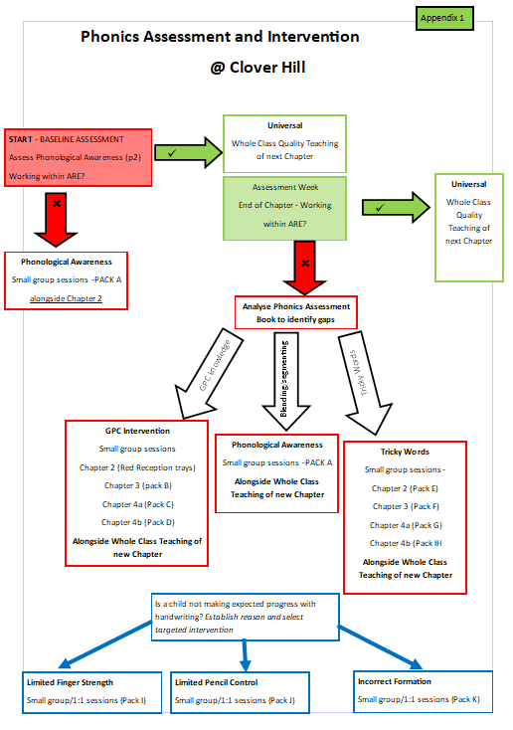

|  |  |  |  |  |  |  |  |  |  |  |  |  |  |  |  |  |  |  |  |  |  |  |  |  |  |  |
| --- | --- | --- | --- | --- | --- | --- | --- | --- | --- | --- | --- | --- | --- | --- | --- | --- | --- | --- | --- | --- | --- | --- | --- | --- | --- | --- |
| **Reception Reading Record**  **Clover Hill Primary School** | | | | | | | | | | | **PAGE 1** | | | | Name:  Appendix 2 | | | | | | | | | | | |
| **Early Learning Goal - Comprehension** | | | | | | | | | | | | | | | | | | | | | | | | | **Date** | |
| * Demonstrate understanding of what has been read to them by retelling stories and narratives using their own words and recently introduced vocabulary | | | | | | | | | | | | | | | | | | | | | | | | |  | |
| * Anticipate – where appropriate – key events in stories | | | | | | | | | | | | | | | | | | | | | | | | |  | |
| * Use and understand recently introduced vocabulary during discussions about stories, non-fiction, rhymes and poems and during role-play | | | | | | | | | | | | | | | | | | | | | | | | |  | |
| **Early Learning Goal – Word Reading** | | | | | | | | | | | | | | | | | | | | | | | | | **Date** | |
| * Say a sound for each letter in the alphabet and at least 10 digraphs | | | | | | | | | | | | | | | | | | | | | | | | |  | |
| * Read words consistent with their phonic knowledge by sound-blending | | | | | | | | | | | | | | | | | | | | | | | | |  | |
| * Read aloud simple sentences and books that are consistent with their phonic knowledge, including some common exception words | | | | | | | | | | | | | | | | | | | | | | | | |  | |
| Ph2 | **s** | | | | **a** | | **t** | | | | **p** | | **i** | | | **n** | | **m** | | **d** | | **g** | | **o** | |
| **c** | | | | **k** | | **ck** | | | | **e** | | **u** | | | **r** | | **h** | | **b** | | **f / ff** | | **l / ll** | |
| Ph3 | **j** | **v** | | **w** | | **x** | | | **y** | **z/zz** | | | | **qu** | | **ch** | **sh** | | **th** | | **ng** | | **ai** | | **ee** |
| **igh** | | | **oa** | | **oo** | | | **ar** | **or** | | | | **ur** | | **ow** | **oi** | | **ear** | | **ure** | | **er** | | **air** |
| Date | | | Read Number | | | | | Title / Band | | | | Comment | | | | | | | | | | | | | | | |
|  | | |  | | | | |  | | | |  | | | | | | | | | | | | | | | |
| Ch set | | |
|  | | |  | | | | |  | | | |  | | | | | | | | | | | | | | | |
| Ch set | | |

Home Reading

Appendix 3

Please sign, date and write a brief comment each time your child reads their book at home. Once a book has been read three times, it can be changed.

|  |  |  |
| --- | --- | --- |
| Title: | | Book Band: |
| READ ONE - decoding | Date: | |
| Comment: | | |
| READ TWO - fluency | Date: | |
| Comment: | | |
| READ THREE - comprehension | Date: | |
| Comment: | | |
| Title: | | Book Band: |
| READ ONE - decoding | Date: | |
| Comment: | | |
| READ TWO - fluency | Date: | |
| Comment: | | |
| READ THREE - comprehension | Date: | |
| Comment: | | |