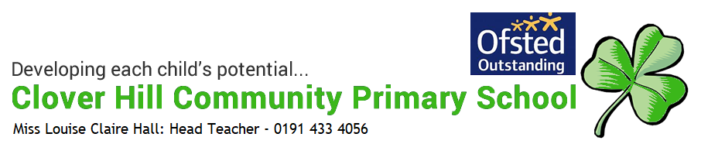

Year 4 Curriculum Map with End Goals

Year Four Curriculum Map

Subject | Autumn | Spring |  | Summer
Literacy | Genre  Narrative – dilemmas  Non-fiction texts reading and writing  Poetry – animal poems both fiction and non-fiction  - Haiku  - descriptive poetry  Journalistic recounts  Grammar  Word classes – nouns, verbs, adjectives  adverbs and prepositions  Fronted adverbials and prepositional phrases.  Expanded noun phrases  Present, past future tense  Verb inflections  Paragraphing  Vocabulary choices – synonyms  Punctuation  Inverted commas and punctuation for dialogue  Apostrophe for possession and contraction  Commas within a sentence (use with fronted adverbial)  Review capital letters, full stops, question marks, exclamation marks.  Class Text  Roman Beanfeast  Stig of the Dump  Lost or Stolen | Genre  Narrative verse - reading/performing  Narrative writing  Explanation texts  Play scripts – reading and writing  Writing fiction  Reading and writing non-fiction  Grammar  Word classes – nouns, verbs, adjectives  adverbs and prepositions  Fronted adverbials and prepositional phrases.  Expanded noun phrases  Present, past future tense  Verb inflections  Paragraphing  Vocabulary choices – synonyms  Punctuation  Inverted commas and punctuation for dialogue  Apostrophe for possession and contraction  Commas within a sentence (use with fronted adverbial)  Review capital letters, full stops, question marks, exclamation marks.  Class Text  The Twits  The Bogey men and the Trolls next door  The Fly and the Fool |  | Genre  Historical Fiction – Reading and writing narrative within a real setting in time and place.  Character studies/writing in role as a character  Features and purpose of a variety of non-fiction newspaper texts. (Reports, adverts)  Stories from another culture  Persuasive writing  Persuasive/balanced arguments  Grammar  Word classes – nouns, verbs, adjectives  adverbs and prepositions  Fronted adverbials and prepositional phrases.  Expanded noun phrases  Present, past future tense  Verb inflections  Paragraphing  Vocabulary choices – synonyms  Standard and non-standard English  Extended speech  Punctuation  Inverted commas and punctuation for dialogue and extended speech  Apostrophe for possession and contraction  Commas within a sentence (use with fronted adverbial, added clauses, within a list)  Review capital letters, full stops, question marks, exclamation marks.  Class Text  The Butterfly Lion  Runaways  Sugar Cane juice
Spelling:  Spelling Shed | 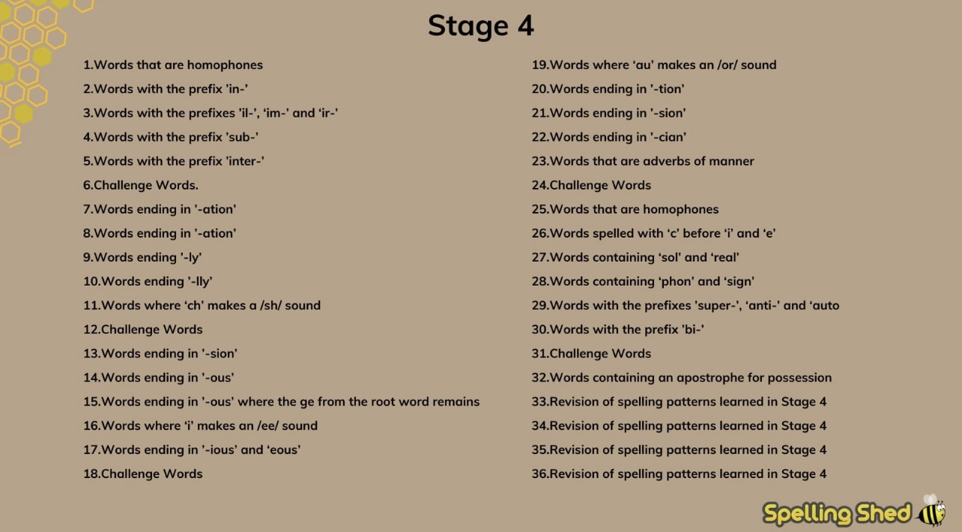
Maths  NC scheme using White Rose to deliver objectives | 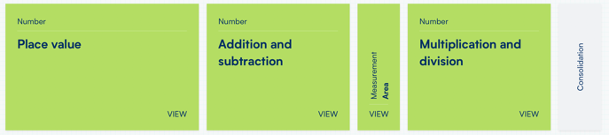 | 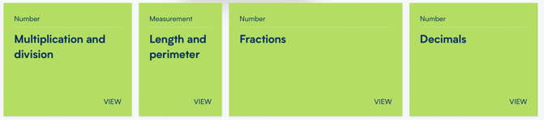 |  | 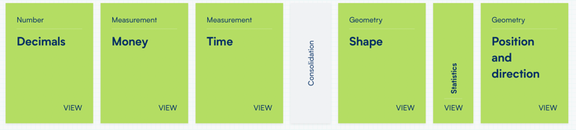
Science | Animals Including Humans  * describe the simple functions of the basic parts of the digestive system in humans.  *identify the different types of teeth in humans and their simple functions.  * construct and interpret a variety of food chains, identifying producers, predators and prey.  Sound  *identify how sounds are made, associating some of them with something vibrating.  *recognise that vibrations from sounds travel through a medium to the ear.  * find patterns between the pitch of a sound and features of the object that produced it.  * find patterns between the volume of a sound and the strength of the vibrations that produced it.  * recognise that sounds get fainter as the distance from the sound source increases. | States of Matter  *compare and group materials together, according to whether they are solids, liquids or gases.  * observe that some materials change state when they are heated or cooled, and measure or research the temperature at which this happens in degrees Celsius (°C)  * identify the part played by evaporation and condensation in the water cycle and associate the rate of evaporation with temperature.  Electricity  * identify common appliances that run on electricity.  * construct a simple series electrical circuit, identifying and naming its basic parts, including cells, wires, bulbs, switches and buzzers.  * identify whether or not a lamp will light in a simple series circuit, based on whether or not the lamp is part of a complete loop with a battery.  * recognise that a switch opens and closes a circuit and associate this with whether or not a lamp lights in a simple series circuit.  * recognise some common conductors and insulators, and associate metals with being good conductors. |  | Living things and their habitats  * recognise that living things can be grouped in a variety of ways.  * explore and use classification keys to help group, identify and name a variety of living things in their local and wider environment.  * recognise that environments can change and that this can sometimes pose dangers to living things.
Working Scientifically in science | Working Scientifically – These skills run across all topics and throughout the key stage.  * asking relevant questions and using different types of scientific enquiries to answer them.  * setting up simple practical enquiries, comparative and fair tests.  * making systematic and careful observations and, where appropriate, taking accurate measurements using standard units, using a range of equipment, including thermometers and data loggers.  * gathering, recording, classifying and presenting data in a variety of ways to help in answering questions.  * recording findings using simple scientific language, drawings, labelled diagrams, keys, bar charts, and tables.  * reporting on findings from enquiries, including oral and written explanations, displays or presentations of results and conclusions.  * using results to draw simple conclusions, make predictions for new values, suggest improvements and raise further questions.  * identifying differences, similarities or changes related to simple scientific ideas and processes.  * using straightforward scientific evidence to answer questions or to support their findings.
R.E | Hinduism – Beliefs and worship  Beliefs, Teaching and sources  *Explore the origins of sacred writings and consider their importance for believers today  *Explore the life of key religious figures and make links with teachings and practices of special significance to followers.  Practices and ways of life  *Compare and contrast the practice of religion in the home in different religious communities.  *Investigate some key features of religious festivals and celebrations and identify similarities and differences  *Investigate the life of a person who has been inspired by their faith and make links between belief and action  Expressing Meaning  *Explore the symbolic use of a range of objects, sounds, visual images, actions and gestures and consider the intended meaning they might have for believers.  *Compare and contrast the use of symbols, actions and gestures used in worship by different  communities.  *Identify some of the ways in which religions name and describe attributes of God and make links with belief and practice. | Hinduism –Celebrations and Festivals  Practices and Beliefs  *Investigate some key features of religious festivals and celebrations and identify similarities and differences  Expressing Meaning  *Explore the symbolic use of a range of objects, sounds, visual images, actions and gestures and consider the intended meaning they might have for believers.  *Compare and contrast the use of symbols, actions and gestures used in worship by different communities.  *Identify some of the ways in which religions name and describe attributes of God and make links with belief and practice.  Identity, Diversity and Belonging  * Explore the diversity of a range of religious traditions and identify and reflect on similarities and differences |  | Christianity  Beliefs, Teaching and Sources  *Explore the origins of sacred writings and consider their importance for believers today  *Explore the life of key religious figures and make links with teachings and practices of special significance to followers  Expressing Meaning  *Explore the symbolic use of a range of objects, sounds, visual images, actions and gestures and consider the intended meaning they might have for believers.  *Compare and contrast the use of symbols, actions and gestures used in worship by different communities.  Values and Commitments  *Explore the meaning of a wide range of stories about the beginning of the world and reflect upon their importance for believers.
P.E.  Complete PE (Year 4 units)  Swimming led by coaches from the local pool across the whole year. | 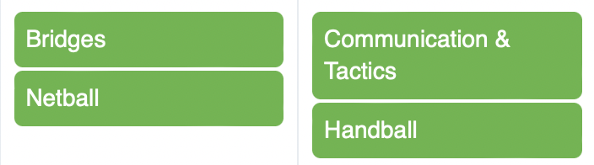  Swimming  Build up confidence and competence in water.  Swim competently, confidently and proficiently over a distance of 25m.  Perform safe self-rescue in different water based situation |   Swimming  Build up confidence and competence in water.  Swim competently, confidently and proficiently over a distance of 25m.  Perform safe self-rescue in different water based situation |  | 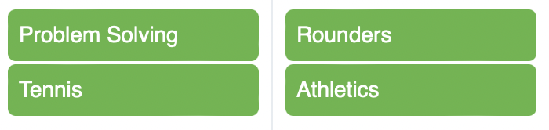  Swimming  Build up confidence and competence in water.  Swim competently, confidently and proficiently over a distance of 25m.  Perform safe self-rescue in different water based situation
Music  Charanga scheme and Recorder Instrumentation | Unit 1 Charanga  Mamma Mia (Pop)  Explore the structure of the song.  Identify the instruments and voices used.  Find the pulse and move in time.  Use recorders and glocks to play and copy back using 2 notes (G,A)  Singing in unison  Play instrumental parts by ear and using notation (G, A, B,)  Improvise using 3 notes (G, A, B)  Compose a melody using simple rhythms from notes G, A, B or G,A,B,D,E  Listen to other song by the same musicians  Perform to an audience.  Reflect on the unit  Recorder Instrumentation  Learn to play the recorder (notes B, A, G, high C and D as well as the notation for the crotchet, minim, semi breve and quaver and corresponding rests)  Unit 2 Charanga  Glockenspiel Stage 2  Explore and develop playing skills using the glockenspiel.  Learn more complex rhythms and patterns.  Revise, play and read the notes C, D, E, F, G  Learn to play:  Mardis Gras Groovin  Two Way Radio  Flea Fly  Rigadoon  Mamma Mia  Revisit tunes from stage 1  Portsmouth  Strictly D  Play your Music  Drive  Compose using the notes C, D, E, F, G  Perform and share music for an audience.  Reflect on the unit  Singing and musicianship for Christmas Carol Service (KS2 | Unit 3 Charanga  Stop (Grime)  Explore the structure of the song.  Identify the instruments and voices used.  Find the pulse and move in time.  Play and copy back simple rhythms using 2 notes C,D.  Sing and rap in unison and in parts.  Compose own rapped lyrics about bullying.  Decide how to perform music and what choreography is to be used.  Reflect on the unit  Unit 4 Charanga  Lean on Me (Soul/Gospel)  Explore the structure of the song.  Identify the instruments and voices used.  Find the pulse and move in time.  Play and copy back simple rhythms using 4 notes C, E, F, G.  Improvise using 3 notes F,G,A  Compose simple melodies using simple rhythms using notes F, G, and A or D, E, F, G and A  Perform to an audience  Reflect on the unit  Recorder Instrumentation  Further develop recorder skills ( notes low C and D, E ,F, dynamic marking and bar lengths) |  | Unit 5 Charanga  Blackbird (Pop)  Explore the themes of equality and civil rights within the songs.  Explore the structure of the song.  Sing in unison.  Find the pulse and move in time.  Play and copy back simple rhythms using 3 notes C,D, E.  Compose own simple melody using simple rhythms from notes C, D and E or C, D, E, G and A  Decide how to perform music and what choreography is to be used.  Reflect on the unit  Recorder Instrumentation  Play a variety of pieces in isolation, rounds and with a number of parts. Perform pieces to others and identify the characteristics of the pieces performed.  Unit 6 Charanga  Reflect and Consolidate  Explore the history of music, look back and consolidate your learning, learn some of the language of music  Appreciate and understand a wide range of high-quality live and recorded music drawn from different traditions and from great composers and musicians.  Reflect on the unit  Singing and performing KS2 End of Year Production.
History | The Romans  *The Roman Empire and its impact on Britain  *The Roman Empire by AD 42 and the power of its army  *The successful invasion by Claudius and conquest, including Hadrian’s Wall  *British resistance - Boudicca  ‘Romanisation’ of Britain: sites as well as the impact of technology, culture and beliefs, including early Christianity.  Skills  Develop a chronological knowledge and understanding of British and local history  Establish clear narratives within and across the periods they study.  Note connections, contrasts and trends over time  Develop the appropriate use of historical terms  Answer and devise historical questions about change, cause, similarity, difference and significance  Select and organise relevant historical information to construct informed responses.  Use a range of sources to construct and develop our knowledge of the past.  Understand that different versions of the past may exist. | Local History Study  * study over time tracing how several aspects of national history are reflected in the locality (this can go beyond 1066)  *a study of an aspect of history or a site dating from a period beyond 1066 that is significant in the locality.  *a significant turning point in British history.  Skills  Develop a chronological knowledge and understanding of British and local history  Establish clear narratives within and across the periods they study.  Note connections, contrasts and trends over time  Develop the appropriate use of historical terms  Answer and devise historical questions about change, cause, similarity, difference and significance  Select and organise relevant historical information to construct informed responses.  Use a range of sources to construct and develop our knowledge of the past.  Understand that different versions of the past may exist. |  | Britain’s settlement by the Anglo Saxon and Scots  *Britain’s settlement by Anglo-Saxons and Scots  *Roman withdrawal from Britain in c. AD 410 and the fall of the western Roman Empire  *Scots invasions from Ireland to north Britain (now Scotland)  *Anglo-Saxon invasions, settlements and kingdoms: place names and village life  *Anglo-Saxon art and culture  *Anglo-Saxon laws and justice  *Edward the Confessor and his death in 1066  Skills  Develop a chronological knowledge and understanding of British and local history  Establish clear narratives within and across the periods they study.  Note connections, contrasts and trends over time  Develop the appropriate use of historical terms  Answer and devise historical questions about change, cause, similarity, difference and significance  Select and organise relevant historical information to construct informed responses.  Use a range of sources to construct and develop our knowledge of the past.  Understand that different versions of the past may exist.
Geography | Cross Curricular links - Locate the Roman Empire in time and place  Locational Knowledge  Use maps, atlases, globes to locate countries and describe features studied.  Use the eight points of a compass, four figure grid references, symbols and key (including the use of Ordnance Survey maps) to build their knowledge of the United Kingdom and the wider world  Locate the world’s countries, using maps to focus on Europe  Human and Physical Geography  Describe and understand key aspects of physical geography, including: volcanoes  Locate areas of the world where volcanoes occur. Describe the structure of a volcano. Appreciate the effects of a volcano on the environment as well as the population.  KS2 Orienteering  Geographical Skills and Fieldwork  Use the 8 points of a compass  Using a map to follow a trail  Use symbols and keys from an OS map  Use 4 and 6 figure grid references | A Local Study of Newcastle  Locational Knowledge  Locate the world’s countries using maps to focus on Name and locate counties and cities of the United Kingdom, geographical regions and their identifying human and physical characteristics, key topographical features (including hills, mountains, coasts and rivers), and land-use patterns; and understand how some of these aspects have changed over time  Human and Physical Geography  Describe and understand types of settlement and land use, economic activity including trade links, and the distribution of natural resources including energy, food, minerals and water  Use basic geographical vocabulary to refer to: key physical features, including: beach, cliff, coast, forest, hill, mountain, sea, ocean, river, soil, valley, vegetation, season and weather – local study of Newcastle  Geographical Skills and Fieldwork  Use maps and atlases to locate counties and describe features studied.  Cross curricular links – Locational Knowledge - French topic Le Monde  Locate France and name and locate the countries that border it.  Identify the key geographical features of France including main Towns, cities, rivers and mountain ranges. Annotate maps to illustrate. |  | Geography links made with Anglo Saxon topic  Where did the Anglo Saxon invaders come from?  Cross curricular Links - Locational Knowledge  Identify and locate the countries from which the Anglo Saxons came.  Use maps, atlases, globes to locate countries and annotate maps to illustrate.  Human and Physical Geography  Describe and understand key aspects of physical geography including earthquakes.  Locate areas of the world which are prone to earthquakes. Understand the reasons why areas are more likely to suffer the effects of an earthquake. Appreciate the effects of earthquakes from a human and environmental perspective.
French  NC objectives delivered through Rachel Hawkes scheme | 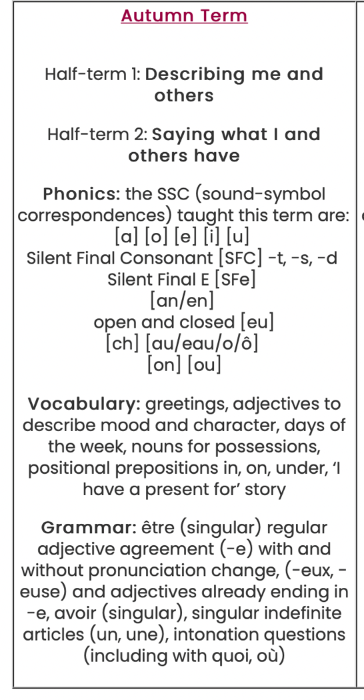 | 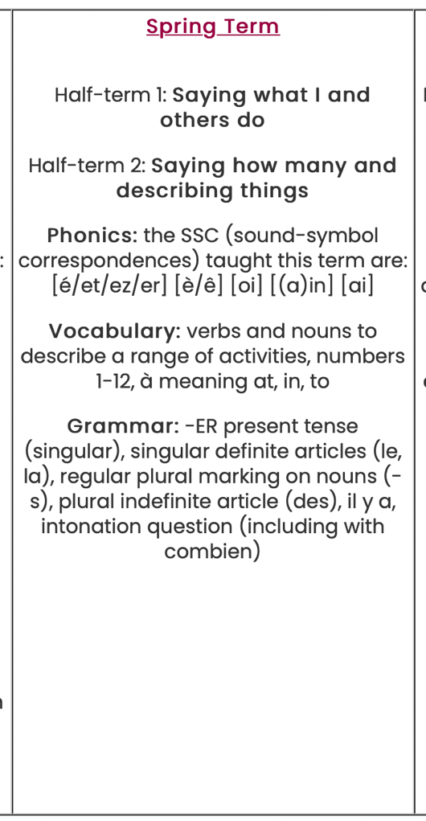 |  | 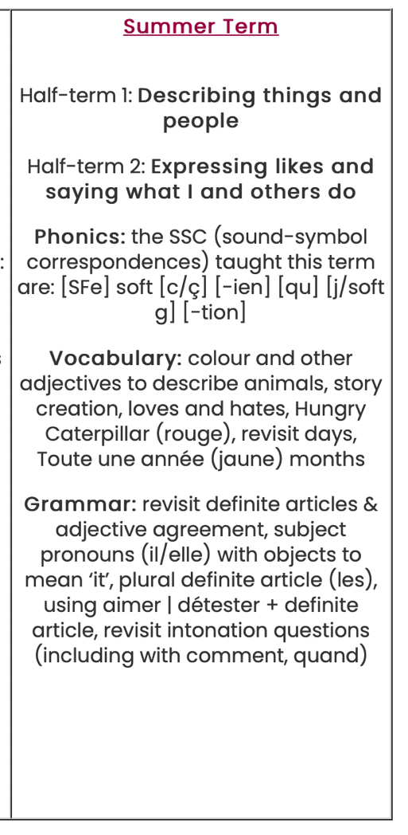
D.T | Cooking and Nutrition (Science)  Understand the principles of a healthy and varied diet and link to autumn science topic when the digestive system is studied. Link to the need for a healthy diet to allow the body to function efficiently.  Textiles sewing task, Roman Bulla Bags to link with Art – see below  Designing and making clay diva lamps as a Christmas gift to link with Art. | Light Up Torches  Create a torch suitable for purpose and particular individuals.  Technical Knowledge  Understand and use electrical systems in their products  Design  Use research and develop design criteria so that the torch is fit for purpose aimed at a specific user  Design a purposeful, functional torch for users based upon design criteria  Generate, develop, model and communicate ideas through discussion, annotated sketches and exploded diagrams  Make  Select and use a wide range of materials and components including construction materials according to their functional properties and aesthetic qualities  Select from and use a wider range of tools and equipment to perform practical tasks  Evaluate  Investigate and analyse a range of existing torches  Evaluate own ideas and finished torches against the design criteria and consider the viewpoint of others to improve their work  Understand how key events and individuals in design and technology have helped shape the world. |  | Anglo Saxon style Cooking  Prepare a stew/pottage which would be a healthy, hearty meal  Cooking and Nutrition  Understand the principles and necessity of a healthy and varied diet.  Link to the idea that the food supply available during Anglo Saxon times would obviously govern meal choices or lack of them.  Understand seasonality and know where and how a variety of ingredients are grown, reared, caught and processed  Anglo Saxon Purse  Design  Use research and develop design criteria so that the purse is fit for purpose aimed at a specific user  Design a purposeful, functional and attractive purse for users based upon design criteria  Generate, develop, model and communicate ideas through discussion, annotated sketches and exploded diagrams  Make  Select and use a range of materials according to their functional properties and aesthetic qualities  Select from and use a wider range of tools and equipment to perform practical tasks.  Evaluate  Investigate and analyse a range of existing torches  Evaluate own ideas and finished torches against the design criteria and consider the viewpoint of others to improve their work  Understand how key events and individuals in design and technology have helped shape the world
Art on going skills | Exploring and developing ideas  Select and record from first hand observation, experience and imagination and explore ideas for different purposes.  Question and make thoughtful observations about starting points and select ideas to use in their work.  Explore the roles and purposes of artists, craftspeople and designers in different times and cultures. |  | Evaluating and developing work  Compare ideas, methods and approaches in their own and others’ work and say what they think and feel about them.  Adapt their work according to their views and describe how they might develop it further.  Annotate own work.  To discuss own work and that of others using appropriate language.  To use appropriate language when describing skills.
Art | Roman Art /Hindu Art  Skills Progression  Drawing  To continue to experiment with different grades of pencils and other implements.  To continue to produce a wide range of different patterns and textures.  To control a pencil with confidence.  To make informed choices in drawing including paper and media.  To alter and refine drawings and describe changes using art vocabulary.  To collect images and information independently in a sketchbook.  To use research to inspire drawings from memory and imagination.  To explore relationships between line and tone, pattern and shape, line and texture.  End Point Art Pieces  Roman Shield with pencil drawn emblems and designs inspired by research.  Painting  To make and match colours with accuracy.  To use more specific colour language e.g. tint, tone, shade, hue.  To choose paints and implements appropriately. To plan and create different effects and textures with paint according to what they need for the task.  To show increasing independence and creativity with the painting process.  To explore the colour wheel.  To organise own work station and to clear away  End Point Art Pieces  Painting Roman shields. Painting Clay diva lamps  Textiles and Collage  To match the tool to the material.  To combine skills more readily – cutting, joining, stitching.  To choose collage or textiles as a means of extending work already achieved.  To refine and alter ideas and explain choices using an art vocabulary.  To collect visual information from a variety of sources, describing with vocabulary based on the visual and tactile elements  End Point Art Pieces  Mosaic designs (paper and real tiles)  Christmas card collage designs  Roman bulla bags – sewing  3D form  To make informed choices about the 3D technique chosen.  To show an understanding of shape, space and form.  To plan, design, make and adapt models.  To talk about their work understanding that it has been sculpted, modelled or constructed.  To use a variety of materials.  End Point Art Pieces  Clay diva lamps | Georges Seurat – Pointillism  Skills Progression  Drawing  To continue to experiment with different grades of pencils and other implements.  To control a pencil with confidence.  To alter and refine drawings and describe changes using art vocabulary.  To make informed choices in drawing including paper and media.  To collect images and information independently in a sketchbook.  To use research to inspire drawings from memory and imagination.  To explore relationships between line and tone, pattern and shape, line and texture.  End Point pieces  Drawing Rangoli Patterns  Sketching outlines for pointillism scenes  Charcoal/pastel fire paintings  Painting  To make and match colours with accuracy.  To use more specific colour language e.g. tint, tone, shade, hue.  To choose paints and implements appropriately. To plan and create different effects and textures with paint according to what they need for the task.  To show increasing independence and creativity with the painting process.  To organise own work station and to clear away  End Point Art Pieces  Pointillism scenes  Pointillism shading and colour  Volcano scenes |  | Anglo Saxon Art  Skills Progression  Drawing  To continue to experiment with different grades of pencils and other implements.  To continue to produce a wide range of different patterns and textures.  To control a pencil with confidence.  To make informed choices in drawing including paper and media.  To alter and refine drawings and describe changes using art vocabulary.  To collect images and information independently in a sketchbook.  To use research to inspire drawings from memory and imagination.  To explore relationships between line and tone, pattern and shape, line and texture.  End Point pieces  Drawings and sketches of Anglo Saxon people (Bayeux Tapestry)  Design and decorate ornate letters inspired by the Lindisfarne Gospels/ Saxon Chronicles.  Draw out designs for a stained glass window  Painting  To make and match colours with accuracy.  To use more specific colour language e.g. tint, tone, shade, hue.  To choose paints and implements appropriately. To plan and create different effects and textures with paint according to what they need for the task.  To show increasing independence and creativity with the painting process.  To organise own work station and to clear away  End Point Art Pieces  Stained glass windows  Paintings of scenes from Boewolf  Textiles and Collage  To match the tool to the material.  To combine skills more readily – cutting, joining, stitching.  To choose collage or textiles as a means of extending work already achieved.  To refine and alter ideas and explain choices using an art vocabulary.  To collect visual information from a variety of sources, describing with vocabulary based on the visual and tactile elements  End Point Art Pieces  Anglo Saxon embroidered purse  Printing  To research, create and refine a print using a variety of techniques.  To select broadly the kinds of material to print with in order to get the effect they want  To explore aspects of resist printing for example marbling, silkscreen or cold water paste.  End Point Pieces  Printing Anglo Saxon themed designs
ICT – Purple Mash | Autumn 1  Online Safety & Core Skills  Use technology safely, respectfully and responsibly; recognise acceptable/unacceptable behaviour;  Identify a range of ways to report concerns about content and contact.  Use search technologies effectively, appreciate how results are selected and ranked, and be discerning in evaluating digital content. Understand the difference between the internet and the world wide web (a service that uses the internet). Show an awareness of, and use a range of internet services.  Purple Mash Online Safety Unit 4.2 – ‘Online Safety’  Autumn 2  Digital Literacy and ICT  Select, use and combine a variety of software (including internet services) on a range of digital devices to design and create a range of programs, systems and content that accomplish given goals, including collecting, analysing, evaluating and presenting data and information.  Create appropriate digital content to achieve a given goal through combining software packages to communicate with a wider audience.  Make appropriate improvements to solutions based on feedback received, and can comment on the success of the solution.  Understand the difference between data and information.  Know why sorting data in a table can improve searching for information.  Can use filters or single criteria searches for information.  Purple Mash activities to support see Y4 computing overview. | Spring 1  Computer Science  Design, write and debug programs that accomplish specific goals  Use logical reasoning to explain how simple algorithms work and to detect and correct errors in algorithms and programs  Design algorithms that use repetition. Use diagrams to express solutions. Use logical reasoning to predict outputs.  Create programs that implement algorithms to achieve given goals. Declare and assign variables.  Purple Mash Unit 4.1 - ‘Coding’  Spring 2  Digital literacy and ICT  Understand computer networks including the internet; how they can provide multiple services, such as the world wide web; and the opportunities they offer for communication and collaboration.  Select, use and combine a variety of software (including internet services) on a range of digital devices to design and create a range of programs, systems and content that accomplish given goals, including collecting, analysing, evaluating and presenting data and information.  Create appropriate digital content to achieve a given goal through combining software packages to communicate with a wider audience.  Make appropriate improvements to solutions based on feedback received, and comment on the success of the solution.  Understand the difference between data and information. Know why sorting data in a table can improve searching for information. Use filters or single criteria searches for information.  Purple Mash activities to support see Y4 computing overview. |  | Summer 1 and 2  Digital Literacy and ICT  Select, use and combine a variety of software (including internet services) on a range of digital devices to design and create a range of programs, systems and content that accomplish given goals, including collecting, analysing, evaluating and presenting data and information.  Assessment: Create appropriate digital content to achieve a given goal through combining software packages to communicate with a wider audience.  Make appropriate improvements to solutions based on feedback received, and comment on the success of the solution.  Understand the difference between data and information.  Know why sorting data in a table can improve searching for information. Use filters or single criteria searches for information.  Purple Mash activities to support see Y4 computing overview.
PHSE  Lead by Special Scheme of work written by ‘Partnership for Children’  ‘Apples Friends’  (Each unit of work comprises 4 sessions)  Blue = Espresso unit  Red = Statutory topics  Green = Apple’s Friends  Financial Education will be taught in the same week(s) as money topic in maths. | Caring friendships / respectful relationships  Healthy bodies, healthy minds  Influences on our health and wellbeing including friends and media and awareness of how these can affect personal health choices.  Apple’s friends module 1-Class agreement  Our feelings and range of emotions  How to feel better  Creating story endings ‘Waking Up’  Families and people who care for me/ being safe/ respectful relationships  Communication - Families and Committed Relationships - The range of relationships we experience in our everyday lives. How to understand the differences between types of relationship we encounter.  Apple’s friends module 2-Listening skills and being a good listener.  Being assertive and saying what you really want to say.  Speaking in difficult situations.  Create a story ending. ‘Weekend Plans’ | Caring friendships  Happy and Healthy Friendships  Solving friendship difficulties. How to act if someone invades your privacy or personal boundaries.  Apple’s friends module 3-What makes a good friend?  Coping with loneliness or rejection.  Problems between friends.  Complete the story, ‘New Neighbours’  Discovery  Similarities and Differences/ Healthy and Happy Friendships  Identity and diversity. Seeing different perspectives and not making judgements based on appearance.  Respectful relationships  Being safe / caring friendships / respectful relationships  Apple’s friends unit 4 -Who can help me?  Steps to good solution.  Against bullying: wishes for our class.  Complete the story “Big Boys Football” |  | Being safe  Apple’s friends unit 5 -Change is part of life.  Different types of change.  Coping with loss.  Complete the story ‘Tommy’s Holiday’  Being safe  Apple’s friends unit 6 -Dealing with disappointment.  Ways to cope with worries.  Complete the story’ End of the Holidays’  Celebrate Together

