**Clover Hill Primary School**

**Progression of Skills**



**History**



**History: Early Years**

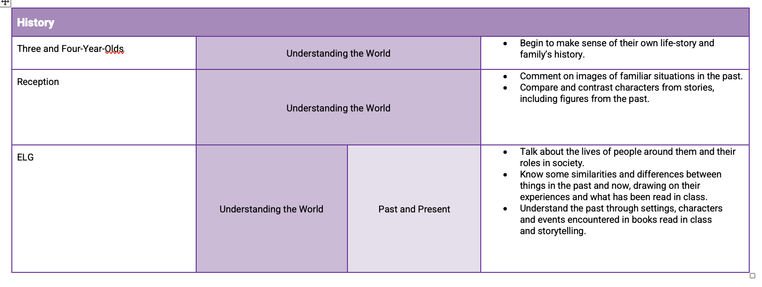



**History National Curriculum Links:**

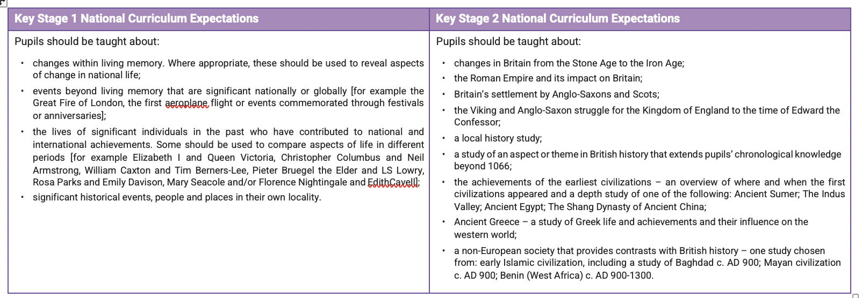



**History Progression of Skills**

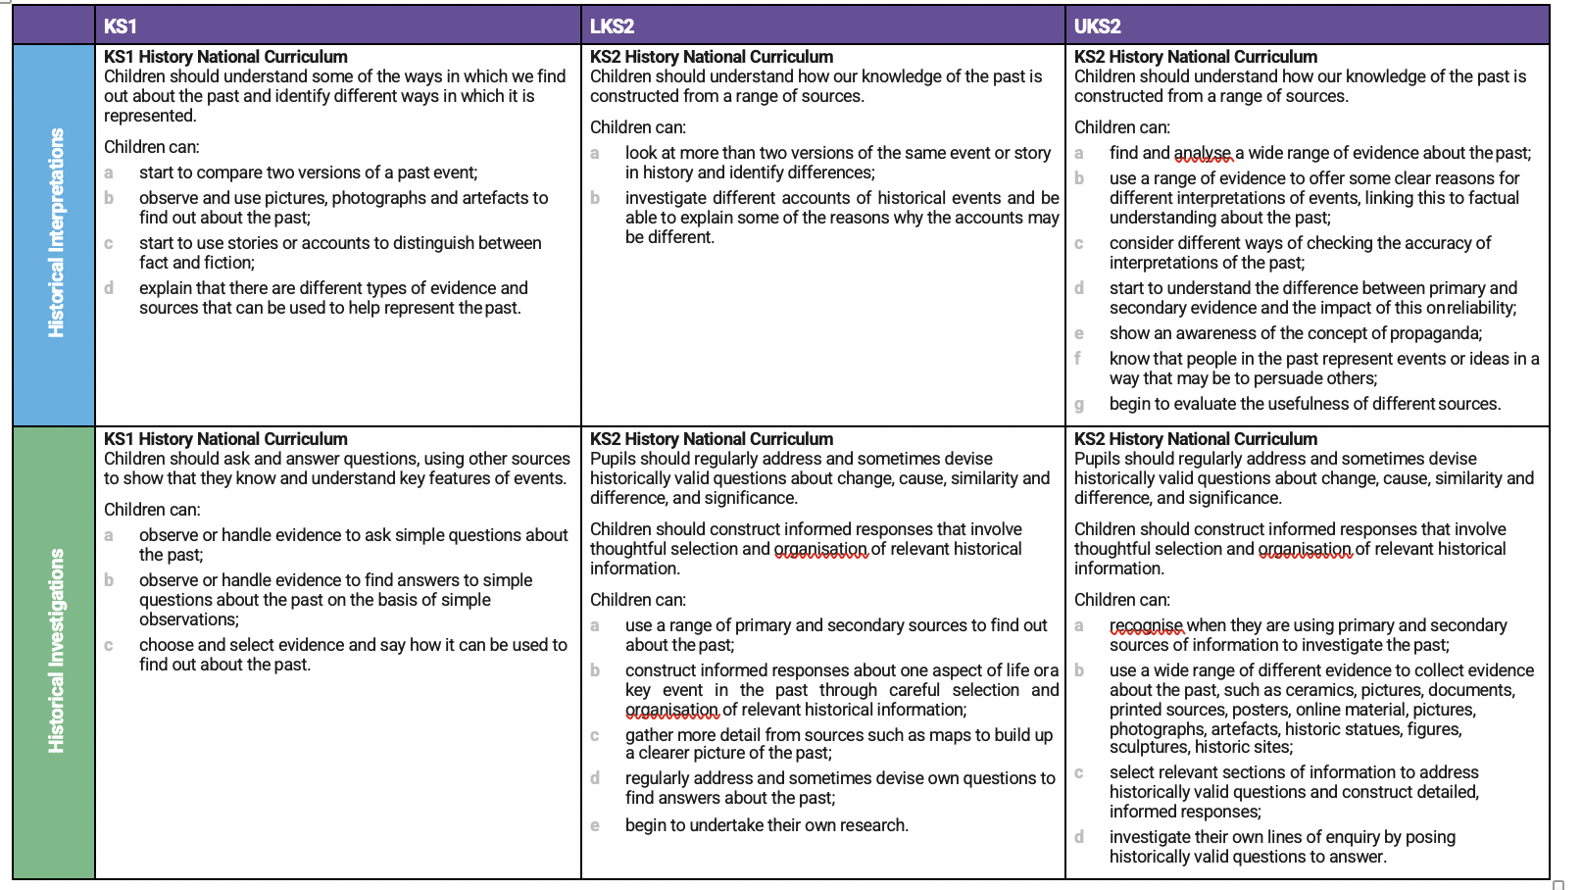



**History Progression of Skills**

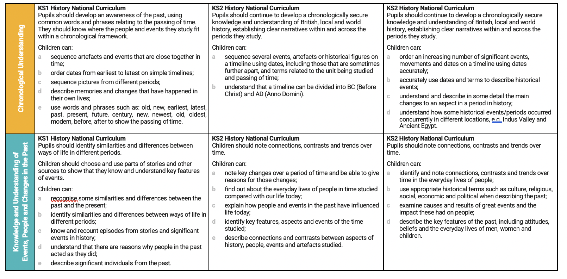



**History Progression of Skills**

