Year 6 | Autumn | Spring | Summer
Genre | Writing Genre  Descriptive writing First person narrative  Non-chronological report Newsreport  Informal letter Diary  Comprehension Focus:  Diary, Explanation, Biography, Narrative, Informal letter, 1st person narrative, Poetry | Writing Genre  Biography  Narrative Formal letter Balanced Argument  Comprehension Focus:  Formal letter, Newspaper, Information text,  Narrative, Biography, Narrative poems | Writing Genre TBC  Comprehension Focus: TBC
Grammar  focus | Grammar  Informal and formal language, Informal and formal speech, Synonyms and antonyms, Active and passive,  Cohesive devices, Layout devices  Always success criteria | Grammar  Revision of KS2 content | Grammar  Revision of KS2 content
Punctuation  focus | Colon and semi colon for lists, Bullet points,  Colon, semi colon and dashes for independent clauses  Hyphens for ambiguity  Always success criteria | Revision of KS2 content  Always success criteria | Revision of KS2 content  Always success criteria
Spelling focus | Spelling Shed  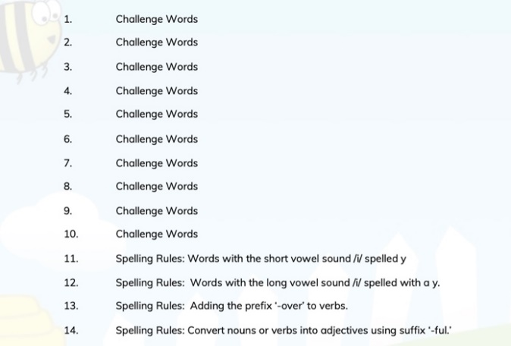 | Spelling Shed  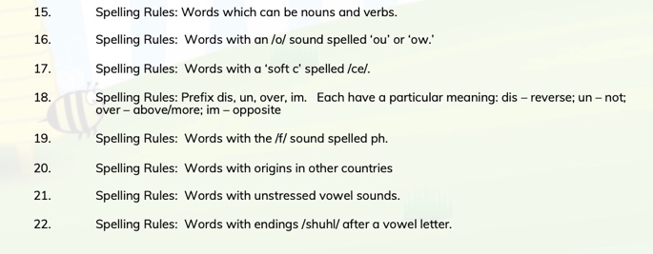  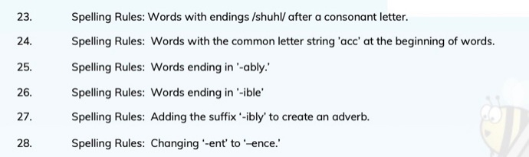 | Spelling Shed  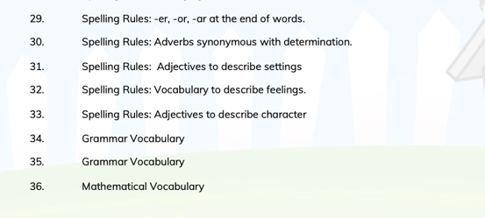
Class reader | Holes – Louis Sachar | Class Text  Streetchild - Berlie Doherty | Class Text  Children’s choice by current popular author
Year 5 | Autumn | Spring | Summer
Genre | Name is Not Refugee  Genre  Diary  Non-chronological reports  Glossary  Fictional story  Journey  Genre  Adventure narrative  Sequel to a story  Remembrance  Poetry  A Christmas Carol & Mrs Scrooge  Genre  Playscript  Balanced argument  Film Review | The Lion Witch and The Wardrobe  Genre  Persuasive speech writing.  Instructive text – truth potion  Greta and The Giants  Genre  Persuasive formal letter  The Lost Thing (7 weeks)  Genre  Diary  Newspaper report  Kennings  Rhyming Couplets  Narrative poem  Setting Description  Informal letter  Comparison and review of one story from 2 different medias. | Lights on Cotton Rock  Genre  Comic strip  Newspaper report  Diary Entry  Poem  Non-chronological report  Tuesday  Genre  Blog  Transcripts  A Midsummer Night’s Dream  Genre  Instructions – spell writing  Character description – Puck  Newspaper article
Grammar  focus | Expanded Noun Phrases  Prepositional Noun Phrases  Fronted Adverbials  Co-ordinating/Subordinating Conjunctions  Variation of sentence length  Personification  Relative pronoun  Relative clause  Parenthesis  Bracket  Dash  Cohesion  Ambiguity  Indirect commas  Commas  Imagery | Figurative language  Imperative language  Hyphens  Expanded Noun Phrases  Prepositional Noun Phrases  Fronted Adverbials  Co-ordinating/Subordinating Conjunctions  Variation of sentence length  Personification  Relative pronoun  Relative clause  Parenthesis  Bracket  Dash  Cohesion  Ambiguity  Indirect commas  Commas  Modal Verbs  Imagery | Figurative language  Imperative language  Hyphens  Expanded Noun Phrases  Prepositional Noun Phrases  Fronted Adverbials  Co-ordinating/Subordinating Conjunctions  Variation of sentence length  Personification  Relative pronoun  Relative clause  Parenthesis  Bracket  Dash  Cohesion  Ambiguity  Indirect commas  Commas  Imagery
Punctuation  focus | Words ending in ‘- tious’ and ‘-ious’  Words ending in ‘- cious’  Words ending in /shul/ spelled ‘-cial’  Words ending in /shul/ spelled ‘-tial’  Words ending in /shul/ spelled ‘-cial’ and ‘-tial’  Challenge Words  Words ending in ‘- ant’  Words ending in ‘- ance’ and ‘-ancy  Words ending in ‘- ent’ and ‘-ence’  Words ending in ‘- able’ and ‘-ible’  Words ending in ‘- ably’ and ‘-ibly’  Challenge Words | Words ending in ‘- able’, where the ‘e’ from the root word remains  Words that are adverbs of time  Words ending in ‘– fer’  Words with ‘silent’ first letters  Words with ‘silent’ letters  Challenge Words  Words spelled with ’ie’ after c  Words where ‘ei’ makes an /ee/ sound  Words where ‘ough’ makes an /or/ sound  Words containing ’ough’  Adverbs of possibility and frequency  Challenge Words | Words that are homophones or near homophones  Words that are homophones  Words that are homophones  Words that are homophones or near homophones  Words that are homophones or near homophones  Challenge Words  Words with hyphens  Challenge Words  Revision of spelling patterns learned in Stage 5 x 4 weeks
Spelling focus | When Hitler Stole Pink Rabbit | N/a | N/a
Class reader | When Hitler Stole Pink Rabbit | Children’s choice by current popular author | Children’s choice by current popular author
Year 4 | Autumn | Spring | Summer
Genre | Narrative – dilemmas  Non fiction texts reading and writing Poetry – animal poems both fiction and non fiction  Haiku - descriptive poetry  Journalistic recounts | Narrative verse.  Explanation texts.  Playscripts.  Evaluating evidence.  Writing with suspense | Historical Fiction – Reading and writing narrative within a real setting in time and place.  Character studies/writing in role as a character  Features and purpose of a variety of non fiction newspaper texts. (Reports, adverts)  Stories from another culture  Persuasive writing  Persuasive/balanced arguments
Grammar  focus | Word classes – nouns, verbs, adjectives adverbs and prepositions  Fronted adverbials and prepositional phrases.  Expanded noun phrases  Present, past future tense Verb inflections  Paragraphing  Vocabulary choices – synonyms | The use of the possessive apostrophe.  a/an, homophones  Use fronted adverbials and use terminology correctly. Revise and edit work proofreading for spelling and punctuation errors.  Look at the effectiveness of adjectives and the importance of selecting the best one for the sentence being created.  Adverbs and adverbial phrases, conjunctions  To use reported speech and direct speech and punctuate correctly.  Prepositions and prepositional phrases  Pronouns and their use to vary vocabulary used within a sentence.  Prepositional words for clarity, conjunctions to express time. | Word classes – nouns, verbs, adjectives  adverbs and prepositions  Fronted adverbials and prepositional phrases.  Expanded noun phrases  Present, past future tense  Verb inflections  Paragraphing  Vocabulary choices – synonyms  Standard and non-standard English  Extended speech
Punctuation  focus | Inverted commas and punctuation for dialogue  Apostrophe for possession and contraction  Commas within a sentence (use with fronted adverbial)  Review capital letters, full stops, question marks, exclamation marks. | Punctuation within a sentence  Commas within sentences to demarcate phrases. | Inverted commas and punctuation for dialogue and extended speech  Apostrophe for possession and contraction  Commas within a sentence (use with fronted adverbial, added clauses, within a list)  Review capital letters, full stops, question marks, exclamation marks.
Spelling focus | Y4 statutory word list  Double consonants  Rules for __ed and __ing suffixes  Homophones, irregular past tense words  Suffixes __al, __ary __ic __ship __hood _ness __ment ___ify ___ate __ise __ity | Plurals –‘f’ to ‘ve’  Plurals (double f)  - ight  - tion  - cial | Use of ‘c’ ‘ck’ ‘k’  ___ious  ‘F’ to ‘ves’ for plurals  Homophones revisit common errors (of/off, know/no/now our/are)  ough / vent / ess  Suffixes ___ful ___ly ___ive  __tion ___ist ___ible ___able ___sion
Class reader | Roman Beanfeast, George's Marvellos Medicine |  | The Butterfly Lion  Runaways  Sugar Cane juice
Year 3 | Autumn | Spring | Summer
Genre | Fiction – significant authors  Humorous poems  Non-chronological reports  Instructions/explanations  Fiction – familiar settings | Fantasy / Sci – Fi Stories  Free Verse Poetry  Discussion Text (Balanced Argument)  Performance Poetry | Aesop’s Fables  Persuasive Writing  Greek Myths  Play Scripts  Recounts
Grammar  focus | Fronted adverbials  Paragraphing  Conjunctions – wider range  Prepositions | Similes  Expanded noun phrases  Powerful verbs  Present perfect, simple past tense  Paragraphing  Onomatopoeia, personification, alliteration | Conjunctions, adverbs and prepositions – time, place and cause  Compound and Complex sentences  Subordinate clauses  Word families
Punctuation  focus | Revise full stops, capital letters, commas, exclamation marks, question marks, Commas in a list  Direct speech  Possessive apostrophes | Revise full stops, capital letters, commas, exclamation marks, question marks, Commas in a list  Direct speech  Possessive apostrophes | Revise full stops, capital letters, commas, exclamation marks, question marks, Commas in a list  Direct speech  Possessive apostrophes
Spelling focus | 2014 New Curriculum words  HFW  Phase 5 phonics  Dictionary skills  Prefixes  Suffixes | 2014 New Curriculum statutory words  Homophones  Adding –er and –est  Plural rules  Silent letters  Compound words  Suffixes –ly, -ful, -less, -able,  Contractions | 2014 New Curriculum statutory words  Prefixes / Suffixes  Prefixes mis-, anti-, re-,  Contractions
Class reader | Charlie and the Chocolate factory – Roald Dahl | The Iron Man (Ted Hughes) | Bill’s New Frock (Anne Fine)
Year 2 | Autumn | Spring | Summer
Genre | Stories with familiar settings  Letters and Postcards  Poetry including Haikus.  Information texts  Diary | Traditional tales from other cultures  Explanation text  Quest and Adventure stories  Non-Chronological text  Senses poetry | Fables  Instructions  Stories by our Champion Author – Anthony Browne  Recounts  Riddles  Poetry – Kennings and Calligrams
Grammar  focus | Compound Nouns  Adjectives  Suffixes  Exclamation sentences – what/how  Conjunctions  Expanded noun phrases | Recap Autumn term  Adverbs  Suffixes  Commands  Verbs – past/present  Present & past progressive | All grammar and punctuation targets are taught in Autumn/ spring terms. Summer term is recap, using in different contexts.
Punctuation  focus | Commas in list  Question marks  Exclamation marks  Capital letters/full stops  Apostrophes for contraction | Apostrophes for possession  Speech marks | All grammar and punctuation targets are taught in Autumn/ spring terms. Summer term is recap, using in different contexts.
Phonic/Spelling focus | 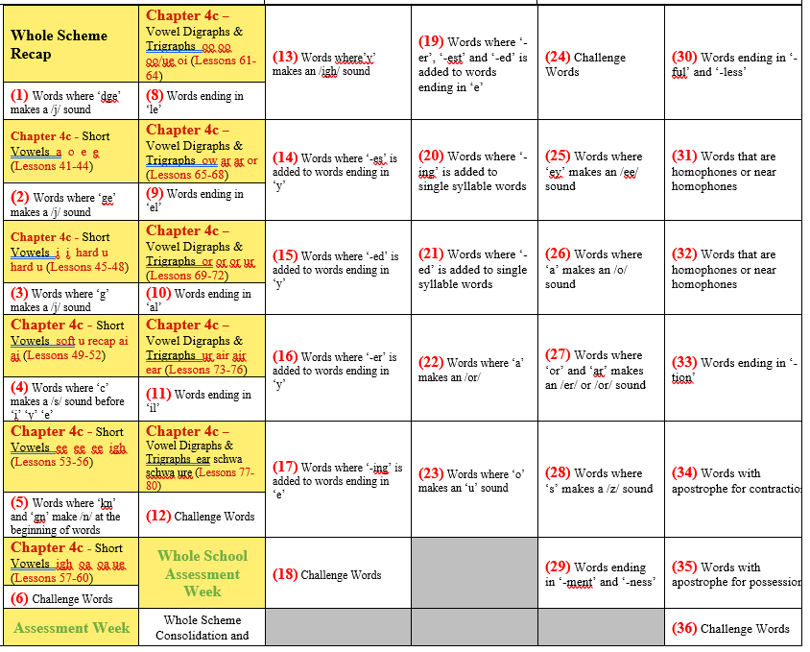
Class reader | Cotton Wool Colin by Jeanne Willis and Tony Ross  Sister for Sale by Adrian Bradbury  Flat Stanley (picture book) by Jeff Brown  The Day the Crayons Quit and The Day the Crayons Came Home  Billy Monster’s Daymare by Alan Durant and Ross Collins  Beauty and the Beast by Gill Howell  Hansel and Gretel, Rapunzel and Little Red Riding Hood by Bethan Woolvin  The Great Fire of London by Emma Adams.  Toby and the Great Fire of London by Margaret Nash and Jane  Cope | How Rabbit Stole the Fire by Joanna Troughton  G.E.M by Jane Clarke and Garry Parsons  Chocolate Planet by Jon Blake  Parents and their Young (Non-fiction)  Journey to the deep (Non-fiction) | The Frog and Scorpion  Ant and Grasshopper  ‘Town Mouse, Country Mouse by Libby Walden and Richard Jones  Various Anthony Browne stories including  Voices in the Park  Silly Billy  Into The Forest  The Tunnel  Zoo  Gorilla  How to turn a Class Hamster into a Dinosaur by Matt Lees
Year 1 | Autumn | Spring | Summer
Genre | Captions  Sentences  Story writing - introduce character, setting, (beginning, middle and end), specific events  Information texts  Descriptions | Sentences  Letters  Information texts  Descriptions  Story writing  Newspaper reports  Recounts  Stories with familiar settings (introduce character, setting, events) | Letters  Information texts  Descriptions  Story writing  Newspaper reports  Recounts
Grammar  focus | Basic Sentence structure (finger Spaces, writing on the line)  Using ‘and’ to join words and clauses  Nouns  Adjectives  Sequencing sentences through discussion, role play and writing | Sequencing sentences to form short narratives  Basic Sentence structure  Using ‘and’ to join words and clauses  Add prefix ‘un’  Add suffixes –s or –es (singular or plural)  Add suffixes –ing, -ed, -er, and –est where no change in spelling is needed | Sequencing sentences to form short narratives  Basic Sentence structure  Using ‘and’ to join words and clauses  Add prefix ‘un’  Add suffixes –s or –es (singular or plural)  Add suffixes –ing, -ed, -er, and –est where no change in spelling is needed
Punctuation  focus | Finger spaces  Full stops  Question marks  Exclamation marks  Capital letters – names, places and ‘I’ and days of the week | Finger spaces  Full stops  Question marks  Exclamation marks  Capital letters – names, places and ‘I’ and days of the week | Finger spaces  Full stops  Question marks  Exclamation marks  Capital letters – names, places and ‘I’ and days of the week
Spelling focus | Phase 2 - intervention  s, a, t, p, i, n, m, d, g, o, c, k, ck, e, u, r, h, b, f, ff, l, ll, ss  Phase 3 phonics  j, v, w, x, y, z, zz, qu, ch, sh, th, ng, ai, ee, igh, oa, oo, ar, or, ur, ow, oi, ear, air, ure, er.  Tricky words  He, she, we, me, be, was, you, they, all, are, my, her.  Grapheme Phoneme Correspondences (GPC’s already taught but revised and consolidated) for all 42 phonemes  Common Exception Words (45 words) introduced slowly but thoroughly throughout the year – currently displayed around the classroom  HFW’s (200 words) introduced slowly but thoroughly throughout the year - currently displayed around the classroom | Phase 4 phonics  During this stage no new graphemes are added to the 42 phonemes however consolidation of phase three is continued. Introduction of polysyllabic words, CVCC words, CCV CCVC, CCVCC words etc are taught for decoding and blending.  Tricky words  Said, have, like, so, do, some, come, were, there, little, one, when, out, what  Phase 5 phonics to be introduced to HA’s and some MA’s  Some children will still require consolidation of Grapheme Phoneme Correspondences (GPC’s already taught but revised and consolidated) for all 42 phonemes  Common Exception Words (45 words) introduced slowly but thoroughly throughout the year – currently displayed around the classroom  HFW’s (200 words) introduced slowly but thoroughly throughout the year - currently displayed around the classroom | Phase 5 phonics  ay, ou, ie, ea, oy, ir, ue, aw, wh, ph, ew, oe, au, ey, a_e, e_e, i_e, o_e, u_e  Tricky words  Oh, their, people, Mr, Mrs, looked, called, asked, could  Some children will still require consolidation of Grapheme Phoneme Correspondences (GPC’s already taught but revised and consolidated) for all 42 phonemes  Common Exception Words (45 words) introduced slowly but thoroughly throughout the year – currently displayed around the classroom  HFW’s (200 words) introduced slowly but thoroughly throughout the year - currently displayed around the classroom
Class Reader | Nitty Winnie – Laura Owen | Horrid Henry – Francesca Simon | The Giraffe, the Pelly and me – Roald Dahl

