Clover Hill Community Primary School

Glenhurst Drive, Whickham, NE16 5SJ

0191 433 4056

Email: cloverhillprimary@gateshead.gov.uk

Website: www.cloverhillprimary.org

Headteachers: Louise C Hall (BA Hons)
Ailsa Holden (BA Hons)

Headteachers’ Message: 18/10/24
Our Harvest Festival today was a wonderful celebration of gratitude and compassion. The children performed poems and sang songs reminding us all to be grateful for the homes, families and lifestyles that we have. Over the past few weeks, we have spoken a great deal about the financial challenges some families face which can often mean they do not have enough food to eat or toiletries for self-care. We are immensely proud of our school's generous spirit demonstrated through the food donations collected for our local foodbank. Your kindness will make a real difference to families in need within our community.

The donations are being collected at the beginning of next week so there is still time to send a little something in if you are able to.

These moments of togetherness and empathy are what make Clover Hill such a special place. They embody the values we strive to instil in our pupils every day. Thank you all for your continued support and for helping to make our Harvest Festival a meaningful and joyous occasion.

Well done to Reception class who performed their very first song to the rest of the school – the Dingle Dangle Scarecrow has never been sang so beautifully before. The children were confident standing up at the front of the hall and made their big Year 6 buddies so proud!!

Halloween Disco: Tuesday 22nd October
Tickets are now sold out for the Halloween disco. KS1 and Reception can come into school on Tuesday wearing their costumes (even if they are not attending the disco) and will be taken to the disco at the end of the day. Collection from the classroom doors as normal at 4.30pm.  KS2 disco is 4.45-5.45pm. Entry via the main gates – please queue outside of Year3/Year4 until the doors are opened. Collection as normal from the playground at 5.45pm. |  |  |  |  | 
Sporting Achievements
Football Team
Well done to our Y5/6 school football team who played brilliantly and demonstrated great sportsmanship in their matches last week. They won one game and lost the second. Excellent ambassadors for Clover Hill.
Tag Rugby Team
Our Y6 Tag Rugby team celebrated wining their tournament last Friday which means they are attending the final on Friday 25th October. We wish them lots of luck!
Our School Website
You can find lots of school information on our website – our letters are saved there, you can find out about our curriculum and what each of the classes have been up to. We have our calendar and term dates on there too. If you are ever in need of information, it’s a good place to start! Additionally, all dates are on our calendar.

Uniform Exchange
Please remember that our ‘Uniform Exchange’ is always open. Drop us an email with the size and items you’d like and we will look through our stock and send them home discreetly with your child in a bag. We are unfortunately closed for donations at the moment.
New Parent Tours
Please pass on the following dates to anyone choosing a primary school for their child to start in September 2025:
13th November 4.45pm
11th December 4.45pm
There will be an opportunity to learn more about our lovely school, meet the headteachers and reception class teacher as well as a guided tour.

Breaktime snacks
Please remember that any snacks at playtime should be healthy. Crisps and chocolate biscuit bars such as Kitkat, Penguins, Party Rings, Twix are not allowed. Cereal bars or a piece of fruit would be ideal.

School Council Friday Healthy Tuck Shop
It was the first day of our new healthy tuck shop ran by the School Council and it proved to be very successful!!
Every item on sale contains healthy fruit and vegetable ingredients- free from dairy, gluten and nuts and costs 60p. Your child is given the opportunity to make 1 purchase every Friday morning playtime.

All profit made will be announced every term and the School Council will decide how it is spent on the children in school at the end of the year.

Items to purchase:
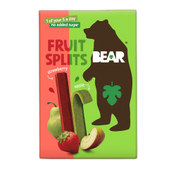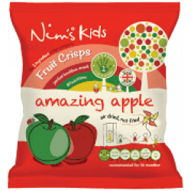

Asda Cashpot for Schools
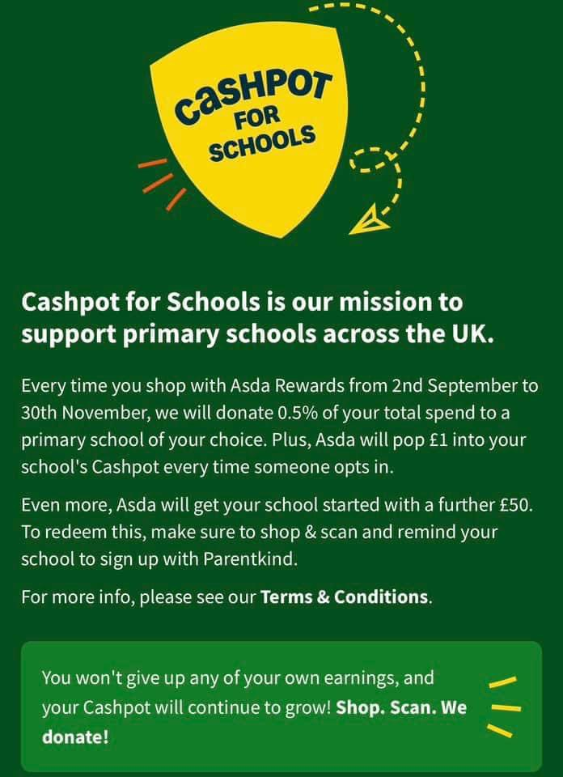 |  |  |  |  |  |  | Did you know ASDA Rewards gives you the opportunity to choose a school when you shop with them?  ASDA will then donate 0.5% of the cost of your shopping, to us. It costs you absolutely nothing but can make a HUGE difference to us.  ANYONE can do this so please start sharing with your friends and family.  Our cashpot total stands at: £291.16  If you’d like to choose us, we would be very grateful!

 | Reception |  | Year 1 | Year 2 |  | Year 3 |  | Year 4 | Year 5 | Year 6
Weekly % | 97.4% |  | 99.7% | 97.5% |  | 96.1% |  | 96.3% | 99% | 95%
Whole School % | 97.3%
Our star class attendance award goes to: Year 1
They will receive 5 extra Marvellous Me points each.

Important diary dates |  | Halloween Disco (information to follow)  Tuesday 22nd October.  KS1 3.45-4.45 KS2 4.45-5.45.  Parent Consultations (information to follow)  25/26/27 November  3.30-5.30pm  KS1 Nativity (further information to follow)  9/10/12 December 1.45pm  KS2 Carol Service (further information to follow)  Friday 20th December 9.15am

