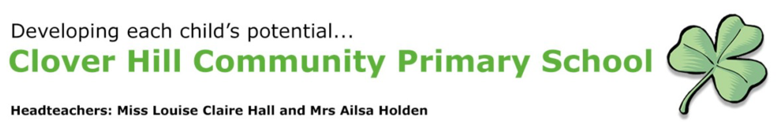

**Year 1 Autumn Newsletter Friday October 25th 2024**

As we reach the half-term break, we would like to take this opportunity to say how proud we are of our children. They have coped with the transition from the Early Years Reception curriculum into the Year 1 National Curriculum so well. Initially Year 1 has reflected on the good practice of the Early Years Curriculum. We wanted to make sure that the children were comfortable and happy to come to school in an environment and routine that is familiar to them. Activities have been based around the Early Years areas of learning before moving on to the Key Stage 1 curriculum.

The move from Reception into Year 1 is a big step in so many ways. The classroom and outdoor area are much smaller, the child-initiated activities are more structured and the learning becomes more formal where children learn to work in groups. Whole class teaching becomes more dominant compared to the group teaching in Reception and children are expected to work on tasks in their books independently for short periods of time.

Our Year 1 boys and girls have all settled in to their new class and routines really easily and are thriving on the new learning taking place.

**Communication**

Once the children leave Reception class, the communication system moves to our Marvellous Me app that continues right through to Year 6. Now that everyone has settled in, we will start to send weekly photos to you showing what we’ve been up to in class. Reception are the only class who use See-Saw and have that two-way communication due to there being two full-time members of staff to manage this. We hope you understand that this is not sustainable in the rest of the school.

**Supporting your child at home**

**Reading:**

We have attached a link to our videos recommended for you as parents to help support your child with the three reads at home. We hope you find this useful – please email us if you have any questions about this. [Clover Hill Primary School - Reading](https://www.cloverhillprimary.org/reading-1) Scroll to the bottom of the site. Don’t forget to accept the cookies!

**Maths Homework:**

Each week your child will be allocated a task to complete on My Maths**.** This will continue through to Year 6.

**Phonics Homework:**

Each week your child will be allocated a task linked to the phonic sounds we have been learning in class. This will eventually feed in to spelling homework in Year 2 using a spelling app called Spelling Shed which is a progression of Phonics Shed.

**Parent Consultations:**

We are looking forward to meeting you on our parent consultation evenings. There will be an opportunity to look at your child’s books and find out about how they have settled into Year 1. Their targets for the term will be shared with you.

**Half-term Round Up – what have we been up to?**

**Phonics:** recap of Phase 3 sounds covered in Reception. New phase 4 sounds introduced were – -oe, -ay, -ew, -ea,- ey, -ie, -aw, -au, -ir and -oy.

**Maths:** We have sorted and counted objects, counted on and backwards, compared numbers and started to use a number line.

**RE:** Christianity – we have explored different groups that people belong to including Christian groups. We have talked about where Christians worship and how they worship – including using The Bible. We have read stories from the Old Testament – Noah’s Ark, Joseph and his multi-coloured coat and David and Goliath. Ask your child to sing you the Noah’s Ark song!!

**PE:** We have explored making shapes in Gymnastics and practised being ‘super gymnasts’. The children had to make wide, narrow and curved shapes both on and off the apparatus. They had to hold their shapes for three seconds. We then progressed onto partner/group work combining all three shapes in a synchronised sequence. Did you see the photos on our website? We were fantastic. We have also worked on our running skills.

**Music:** We have been learning about pitch, beat and tempo whilst singing new songs. We also used the glockenspiels for the first time… that certainly was an experience!!!

**History**: We explored how homes have changed over time. We have looked at how technology has changed- comparing washing then and now, toys from the past and the inventions of Joseph Swan. Thank you to everyone who took the time to complete our parent questionnaire for our toys from the past lesson.

**Geography**: We have looked at features of our local area. We have gone on a tour of the school (that was fun!), explored how to use a map and thought about what we see on our way to school. Year One also researched key landmarks of the local area.

**Science**: We have explored the different seasons and how the weather changes throughout the year.

**PSHE**: We have looked at healthy relationships and how to be a good friend.

**Art**: We have looked at the work of the sculptor, Barbara Hepworth. We sketched designs of our own and worked in groups to create similar sculptures using a variety of boxes.

**English**: We have worked on composing sentences correctly and looked at the features of diary writing to help us create our own diary entries.

We hope you have found our newsletter useful – we know how children love to come home and say ‘they’ve done nothing at school’!! This certainly is not true – quite the opposite in fact!

Have a lovely half term holiday – the children have certainly earned it.

**The Year 1 Team**