Clover Hill Community Primary School

Glenhurst Drive, Whickham, NE16 5SJ

0191 433 4056

Email: cloverhillprimary@gateshead.gov.uk

Website: www.cloverhillprimary.org

Headteachers: Louise C Hall (BA Hons)
Ailsa Holden (BA Hons)

Headteachers’ Message: 25/10/24
Wow – what at half term this has been! The past 8 weeks have been action-packed and full of fun, positivity and successful learning. It’s been fantastic to see the children settling in to their new classes and new roles in school – they really are thriving.

We have had a number of visitors to our school in the past few weeks and each time we have found ourselves beaming with pride. We are a wonderful school with so many amazing qualities shown every day. Our children are confident, friendly and ready to learn during their time here.

We do know that some children need support in different ways. Our school is committed to supporting all children and signposting to external support (that we can work in partnership with) if we are not able to offer what is needed in school ourselves. This is our commitment to you and your child.

Thank you once again for your support and involvement in our school community – working in partnership with you really does ensure our children ‘reach for the stars and shine!’.

Don’t forget the clocks go back this weekend – an extra hour in bed! Enjoy your half-term break!

Mrs Holden & Miss Hall

Harvest Festival – Thank you!
Our harvest festival donations were collected on Thursday by Newcastle West End Food Bank. The team there were exceptionally grateful - our contributions will significantly help local families in who are currently facing financial difficulties. Thank you for showing such kindness and generosity.

Halloween Disco
This event was a fantastic success filled with fun and games, dancing and spooky trick or treat bags. The children’s costumes were amazing!  A special thank you must go to our ‘disco committee’ – Isla H, April, Tabitha in Y4, Sophia T and Haven in Y5 and Lauren, Layla, Liv, Lily in Y6 for making flyers to go to parents, posters for the disco games and most importantly the ‘trick or treat’ bags of goodies!!! They have worked hard during lunch breaks to put this all together.  The event raised £687 which will go into School Fund and pay for the added extras to our curriculum such as the Music Extravangza Workshop (Wednesday 27th November) and subsidise our whole school trip to the pantomime (Wednesday 11th December). |  |  |  |  |  |  | 
KS1 and Reception Nativity
Looking ahead, we are excited to announce the performances of our KS1 Nativity, titled "Prickly Hay". The shows are scheduled for the 9th, 10th, and 12th of December, starting at 1.45pm each day.
Please keep an eye out for more information regarding tickets and costume details which will be sent out shortly.

Parent Consultations
We would like to remind you of the upcoming parent consultations on the 25th, 26th, and 27th of November, running from 3.45pm to 5.30pm. These meetings are a great opportunity to discuss your child’s progress with their teacher and we encourage you to attend.

Uniform Exchange
Please remember that our ‘Uniform Exchange’ is always open. Drop us an email with the size and items you’d like and we will look through our stock and send them home discreetly with your child in a bag. We are unfortunately closed for donations at the moment.
New Parent Tours
Please pass on the following dates to anyone choosing a primary school for their child to start in September 2025:
13th November 4.45pm
11th December 4.45pm
There will be an opportunity to learn more about our lovely school, meet the headteachers and reception class teacher as well as a guided tour.

Asda Cashpot for Schools
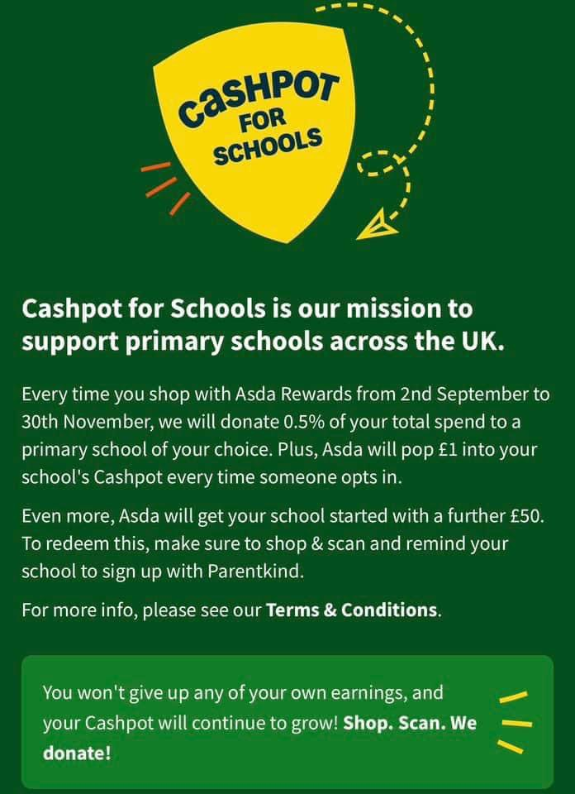 |  |  |  | Did you know ASDA Rewards gives you the opportunity to choose a school when you shop with them?  ASDA will then donate 0.5% of the cost of your shopping, to us. It costs you absolutely nothing but can make a HUGE difference to us.  ANYONE can do this so please start sharing with your friends and family. If you’d like to choose us, we would be very grateful!  Our cashpot total stands at: £308.78

AUTUMN 1 | Reception |  | Year 1 |  | Year 2 | Year 3 |  | Year 4 | Year 5 | Year 6
Weekly %
Whole School %
Our star class attendance award FOR THE HALF TERM goes to: Year
They will receive an extra playtime first week back.

Important diary dates |  | Parent Consultations (information to follow)  25/26/27 November  3.30-5.30pm  KS1 Nativity (further information to follow)  9/10/12 December 1.45pm  KS2 Carol Service (further information to follow)  Friday 20th December 9.15am

