Secrets of Success at Clover Hill Primary School
We are working hard to ensure our children have the optimum behaviour and attitude to their learning. We want them to be highly motivated and engaged, to have high expectations of themselves and are ambitious to want to achieve success.
We want to remove any barriers to their learning and develop their brain power. Learning brains make smarter decisions and happier societies!

What is success?
Success isn’t just about money. It is about happiness, choices and feeling good about yourself. Successful people feel good about:
- How hard they have tried
- Who they are
- What they spend their time doing
- The choices they have made in their lives.
Here are some things everyone should know…
- You are not born successful.
- Everyone has setbacks and failures
- The first step to success is choosing…. do you want to be successful?

Personal Development needs to be central to the curriculum- driving the basic skills. Children learn best when they use their whole brain in sensory based learning using multiple intelligences. Children need to have the right attitude to learning: motivation, energy and determination to learn. They need to buy in. What’s in it for me? Attitude is 80% of performance

There are 8 recognised Secrets of Success which we are working hard to improve for all of our pupils:

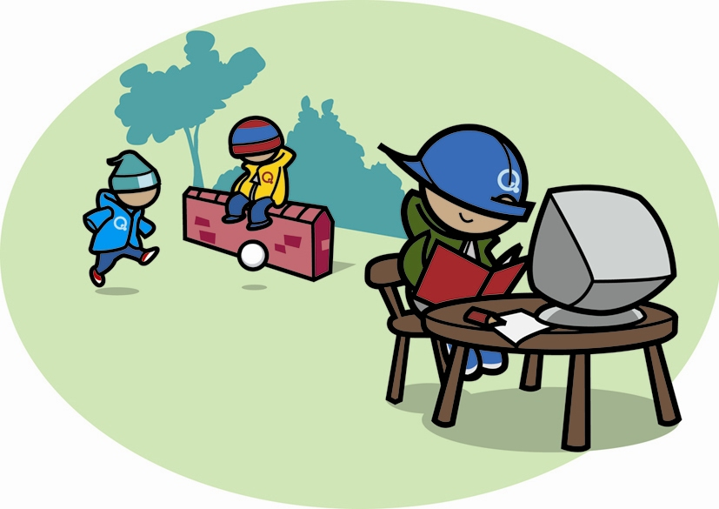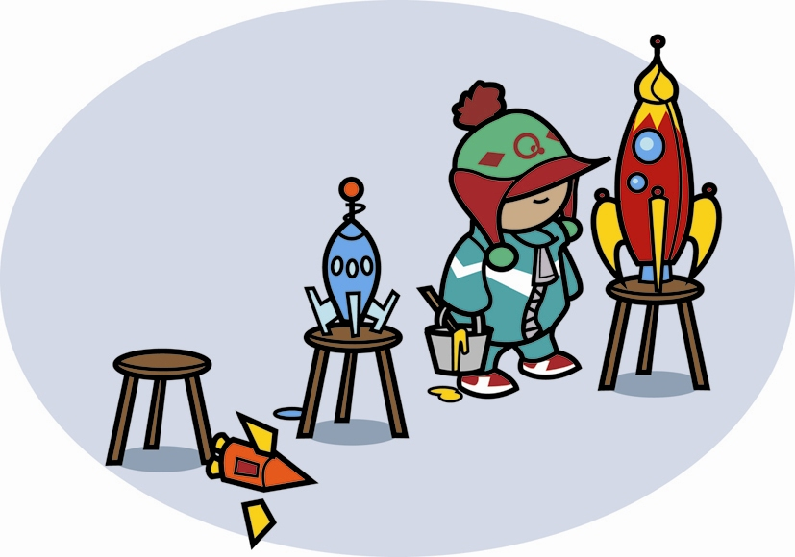
Concentrate Improve
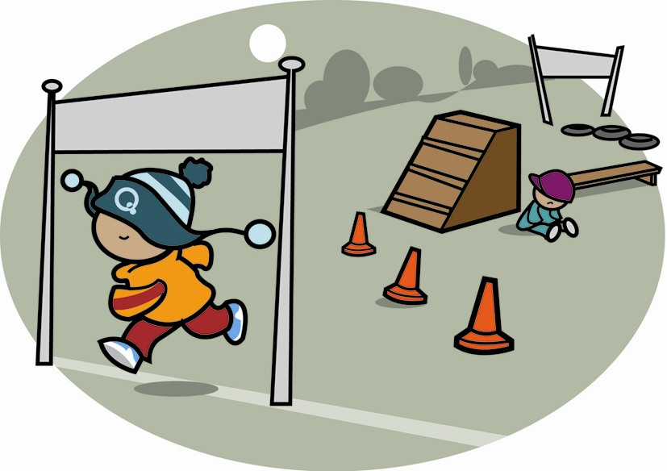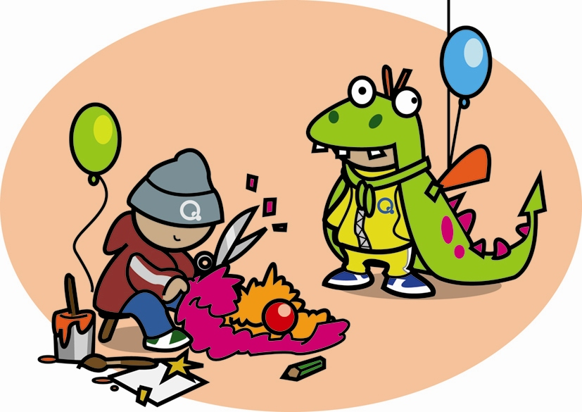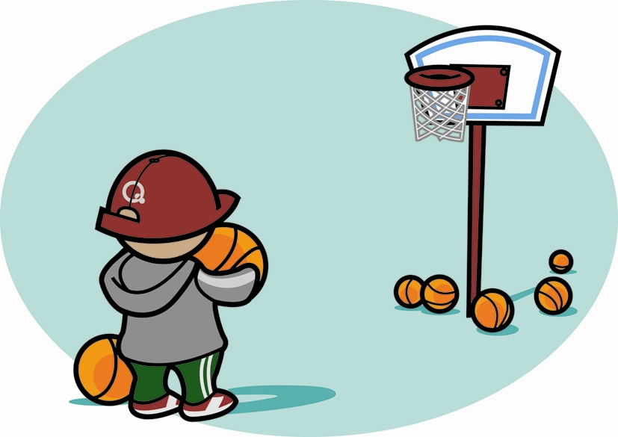
Don’t give up Imagine Push yourself

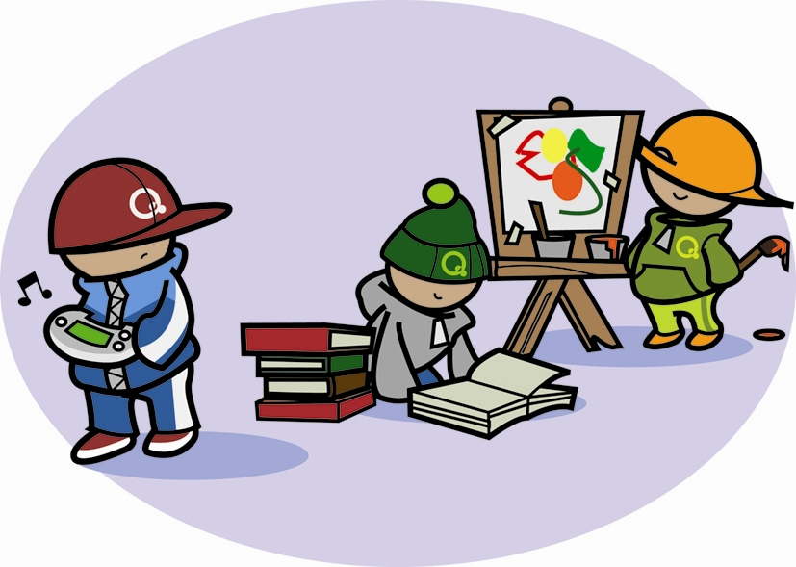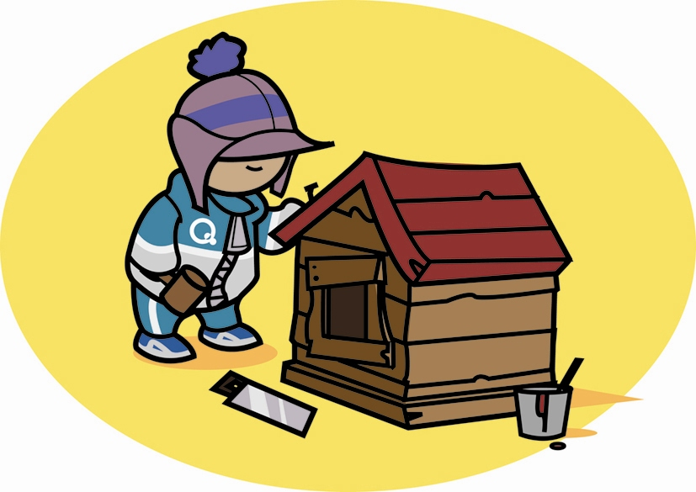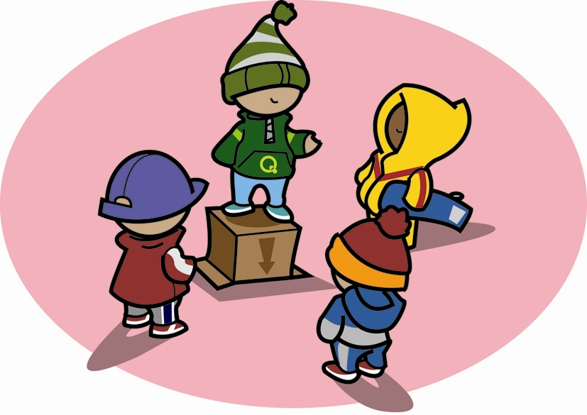
Try new things Work hard Understand others

- Try new things
If you never try- you might never find things you are successful at. If you love what you are doing you get energy and are motivated. We all need to ensure children try new things, take risks, give things a go!

- Work hard
We need to teach our children that whatever they choose to do in life – they do it to the very best of their ability. Success is not easy- there is no overnight success just hours and hours of work.
The difference between try and triumph is a little umph. Work is GOOD. HARD work is even better!!
Successful people don’t make fun of work because they know it leads to success.
They have a good attitude to work. In fact successful people have fun working.

- Concentrate
Children need to tune out distractions –day dreaming, peer pressure etc. They need to learn to focus their attention on all the right things. Zero tolerance to temptations.They need to be clear about what they are doing and why. Once you are really clear about what you are doing, it is much easier to concentrate. If you really concentrate you can become an expert. Concentration that leads to success isn’t just about getting on with something- it is about doing the right things well!

- Push yourself
Life isn’t easy. There will always be self doubts and barriers- we need to teach our children to push past them and never give up. Parents and teachers need to push the children- nudging them every step of the way. Children also need to take responsibility for their own choices and actions and have the determination to ‘push past’ barriers and set backs.

- Imagine
We all need new ideas to help us to move on and progress. Inventions have revolutionised the world!
Children need to try out, investigate and explore. Improve and get better. They need to have confidence to voice their ideas. Children need to know that they can get better and can imagine how they will feel, what things will be like when they taste success.
If you visualise something so strongly – your brain will work hard to make it happen. Getting the Vision right can be very powerful. However, some children are put off because the distance to cover can look too great- and so just give up. What we need to do is to help them imagine small steps and aspire to get a bit better each week.

- Improve
Opportunities to try things out and get better. This needs to be built in consistently over time. ‘Use the new knowledge or lose it.’ We are ensuring our children get lots of opportunities to reinforce their knowledge-‘recall for retention.’ Children need to be given lots of opportunities to improve their skills across the curriculum. Learning is not just about being taught something it’s about using it again and again, getting better at it each time.

- Understand others
To be successful you need to communicate and cooperate with others. Successful people don’t just think about themselves. They are good at listening to others, sharing ideas and making compromises. They can reflect on their work and actions. We need to teach our children about group dynamics, how to communicate and work with others productively.

- Don’t give up
Even successful people suffer rejection and criticism. Children need to bounce back- they need to have self worth and self belief. We are teaching our children that ‘the barrier’ is not going to stop them- they just need to think of ways to get around it. We need to teach children resilience- it is a tough world but they need to be tested-to see where they went wrong, how to improve and bounce back!

