
Year 6 Summer Term Newsletter
Dear Parents/Carers
Our last term together! We cannot believe how fast this year has gone.

The Summer term is a busy time for Year 6. We have our residential to Weardale, a visit to Gibside National Trust for an ‘orienteering day’ and an enterprise week where Year 6 will become entrepreneurs.

We need to start thinking about our Year 6 leavers’ treat and finally we will be planning our ‘Y6 Celebration (Leavers) Assembly’ which always provides a very poignant and memorable experience celebrating the fantastic experiences and talents of our amazing Year 6 children.

Our work this term will be based around the topic of ‘The Mayans’. We will also be engaged in the following activities in each subject area:

Year 6 Summer Term Curriculum
English | We shall be covering a wide range of genre during English lessons based on our class text ‘Wildboy’ and through topic work.
Maths | We will be concentrating on arithmetic and reasoning, carrying out mathematical investigations.
PE | Athletics, rounders, badminton, orienteering
RE | Islam – The Qur’an
Computing | Blogging, Text Adventures
DT | Designing and making a Mayan mask
Art | Mayan art – clay pots, sketching. Collage posters
Science | Investigative Science tasks linked to Healthy Bodies and Classification of Living Things
History | Study of a non European society that provides contrast with British history – Mayan civilisation
Geography | Using maps and atlases, understanding similarities and differences through the study of physical and human geography of NE England to the Americas
French | Developing reading, writing and oracy skills in French grammar, phonics and vocabulary.
PSHCRE | Coping with Change, Puberty (details to follow)

Useful diary dates:

SATs week

School opens at 8.20am for Year 6 pupils to come in and enjoy a breakfast before SATS! We would like ALL children to attend please.
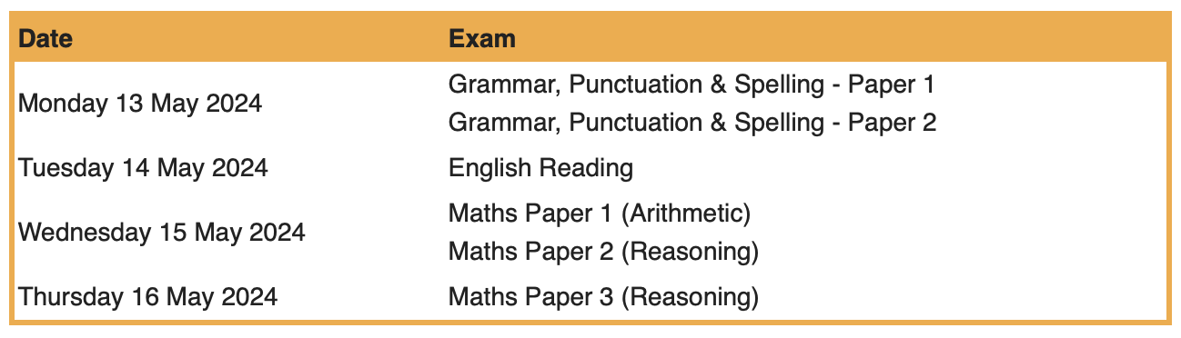
Year 6 Residential
Wednesday 18th April – Friday 19th April.

Year 6 Wellbeing Day at Gibside National Trust.
Monday 20th May. Packed lunch required.

Orienteering Day at Gibside
Friday 7th June. Packed lunch required and school uniform. Dress according to weather on the day. See separate letter for full information.

Year 6 Transition Days
Monday 1st - Tuesday 2nd July. Whickham School all day.

Occasional Day
Friday 21st June – school closed

Sports Day – Year 6 to lead
Wednesday 10th July

Leavers’ Assembly
Friday 19th July 9.15am

School closes for Summer
Friday 19th July

Reminders:

We would like to take this opportunity to commend the children on how hard they have worked this year. They have been absolute delights to teach and are shining role models to the rest of the school. We are sure you have noticed how mature they have become – we are very proud of them and their attitude and commitment. They are certainly ready to begin the next stage of their journey.
Please do not hesitate to get in touch, should you have any questions or concerns regarding your child. Our door is always open.
Kindest Regards
The Year 6 Team

