Recommended Digital Resources for Young People
Apps
SAM  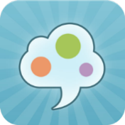  Self help for anxiety management  Phone app | For all ages.  Designed to help people manage and record their anxiety. Users can record their anxiety levels and identify different triggers.  The app includes 25 self-help options to help users cope with the physical and mental symptoms of anxiety.
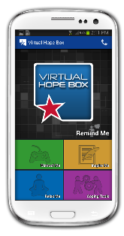  Virtual Hope  Phone app  iTunes and Google Play | The Virtual Hope Box (VHB) is designed as an accessory for treatment. Contains simple tools to help patients with coping, relaxation, distraction and positive thinking.  Users can choose from different activities – distract me, inspire me, relax me and coping tools.
  Smiling Minds  Phone app  iTunes and Google Play | For all ages (from 7 years+)  Guided meditations, bite size options, categorised in age groups. Helps with thoughts and feelings and to self check on mood.
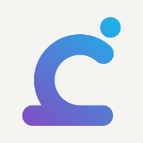  Calm Harm  Phone app  iTunes and Google Play | For young people who have already started the process of gaining an understanding of their self harm issues  Provides tasks to resist or manage the urge to self harm.  Four categories of tasks – distract, comfort, express, release.
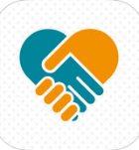  Stay Alive  Phone app | This app is a pocket suicide prevention resource, packed full of useful information to help young people stay safe. It can be used if someone is having thoughts of suicide or if they are concerned about someone else who may be considering suicide.  In addition to the resources, the app includes a safety plan, customisable reasons for living, and a life box where photos that are important to the user can be stored.  More specific to Brighton and Hove for services
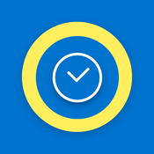  WorryTime  Phone app  iTunes and Google Play | Ages 12+  The theory behind app is that you can’t control the thoughts that pop into your head but you can control what you do with them.  This app allows users to control everyday stress and anxiety by acting as a place to store your daily worries.
Mindfulness Daily  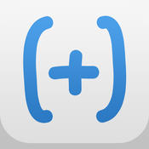  Phone app  iTunes and Google Play | For relaxation, stress management, support for depression and anxiety.  *great feedback from a young person who used it for anxiety and panic attacks
WellMind  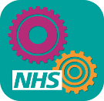  Phone app  iTunes & Google Play | For All ages  Designed to help cope with stress, anxiety and depression. Includes advice, tips and tools to improve mental health and boost well-being.
  Breathe2Relax  Phone app iTunes & Google Play | Breathe2Relax is a hands-on diaphragmatic breathing exercise tool.

Websites
ReachOut Australia | Not a UK website but a great resource
Young Minds | A great resource covering most mental health issues
Self harm UK | Dedicated to young people who self harm.  For young people at the beginning for their recovery journey.

YouTube Channels
WatchWellCast | YouTube videos. An excellent resource. Short videos developed in a way that are accessible to young people

